Permanent Mission of Rwanda
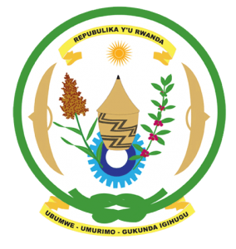
34th Session of the Universal Periodic Review Working Group
Review of Madagascar
11th November 2019
Statement delivered by H.E. Marie Chantal Rwakazina
Thank you, Mr. President,
Rwanda warmly welcomes the delegation of Madagascar and thanks them for the presentation of their national report and the update just provided and commends Madagascar for the positive steps taken to implement the recommendations of its last UPR.

We commend the efforts undertaken by Madagascar to strengthen the institutional and policy framework for the promotion and protection of human rights including through legislative reforms. We welcome Madagascar’s ratification of the Second Optional Protocol of the ICCPR and the CRPD. We further take positive note of the measures taken to combat gender-based violence and to foster women’s economic empowerment.

Rwanda recommends that Madagascar:
- Ratify the Convention on the Prevention and Punishment of the Crime of Genocide
- Strengthen measures to combat discrimination and violence against women including through; the implementation of relevant laws, eliminating any loopholes in national legislation that might undermine the protection of women’s rights and addressing discriminatory stereotypes that affect women.
We wish Madagascar a successful review outcome.

