Permanent Mission of Rwanda
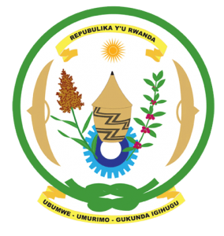
34th Session of the Universal Periodic Review Working Group
Review of Angola
7th November 2019
Statement delivered by H.E. Marie Chantal Rwakazina
Thank you, Mr. President,
Rwanda warmly welcomes the delegation of Angola and thanks them for the presentation of their national report.

Rwanda welcomes the positive steps taken by Angola to implement the recommendations of its last UPR including through the adoption of legislation and implementation of policies aimed at the promotion and protection of human rights. Rwanda particularly commends Angola’s efforts to improve the social and economic wellbeing of its people. We further welcome Angola’s accession to the ICERD, the CAT and the Second Optional Protocol to the ICCPR and look forward to their domestication into national legislation.

Rwanda recommends that Angola:
- Ratify the Convention on the Prevention and Punishment of the Crime of Genocide
- Strengthen measures to prohibit all forms of violence against women and girls in both the public and the private spheres including through the adoption of comprehensive legislation to prevent, combat and punish all forms of violence against women and girls.

Rwanda wishes Angola a successful review. Thank you

