Permanent Mission of Rwanda
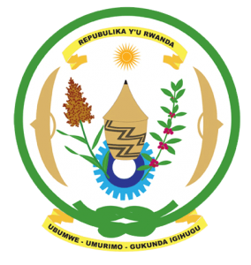
34th Session of the Universal Periodic Review Working Group

Review of Fiji

6th November 2019

Statement delivered by Mr. Moses Rugema

Thank you, Mr. President,
Rwanda warmly welcomes the delegation of Fiji and thanks them for the presentation of their national report and the update just provided.

Rwanda welcomes the positive steps taken by Fiji to implement the recommendations of its last UPR. Rwanda commends Fiji’s establishment of a robust legislative and policy framework to mitigate and adapt to climate change and to build a strong and resilient society in the face of climate change and natural disasters. We call on the international community to support these efforts and offer our own modest support in that regard.
Rwanda recommends that Fiji:
- Strengthen measures to protect victims of violence against women and girls including through full implementation of relevant legislation, awareness-raising campaigns and the establishment of shelters for survivors with integrated counselling services.
- Continue its mainstreaming of climate change adaptation across its developmental activities with the assistance of the international community.
We wish Fiji a successful review outcome. Thank you

