Permanent Mission of Rwanda
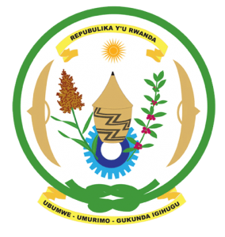
34th Session of the Universal Periodic Review Working Group

Review of Italy

4th November 2019

Statement delivered by Mr. Moses Rugema

Thank you, Mr. President,
Rwanda warmly welcomes the delegation of Italy and thanks them for the presentation of their national report.
Rwanda commends Italy for the steps that it has taken to implement the recommendations of its last UPR including the adoption of legislation and implementation of policies aimed at the promotion and protection of human rights in Italy.
While taking positive note of the update provided this morning, Rwanda recommends that Italy:
- Strengthen its efforts to establish a national human rights institution in compliance with the Paris Principles.
- Strengthen the legislative framework on gender equality including through adopting laws and policies to increase women’s representation in political affairs.
- Strengthen its efforts to fight discrimination, including by enhancing institutional capacity to systematically document, investigate and prosecute incidents of racism, racial discrimination, xenophobia and related intolerance.

We wish Italy a successful review outcome. Thank you

