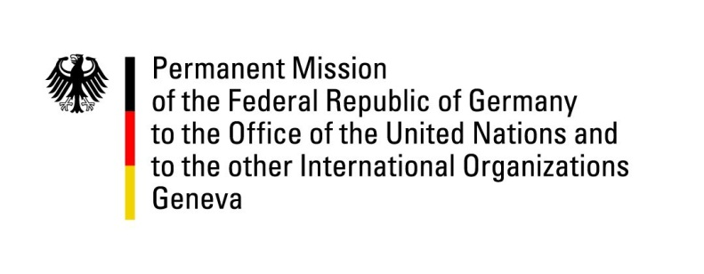

United Nations Human Rights Council

34th Session of the UPR Working Group

Geneva, 12 November 2019

Recommendations and advance questions to
Slovenia

Thank you, Mr President.

Germany warmly welcomes the delegation of Slovenia to the UPR. We commend Slovenia on its engagement in advocating for and upholding human rights, and we appreciate the efforts undertaken to implement the recommendations of previous UPR cycles.

Germany wishes to make the following recommendations:
- Continue efforts to improve the living conditions of Roma and particularly ensure the right to drinking water for everyone as laid down in the Constitution of the Republic of Slovenia.
- Continue to reduce the backlog of judicial cases by further improving the staffing and financial resources of the courts.

Thank you, Mr President.

GERMAN ADVANCE QUESTION TO SLOVENIA:

- Which concrete measures have already been taken, and will be taken, to ensure full access to water, sanitation and electricity for Roma?

