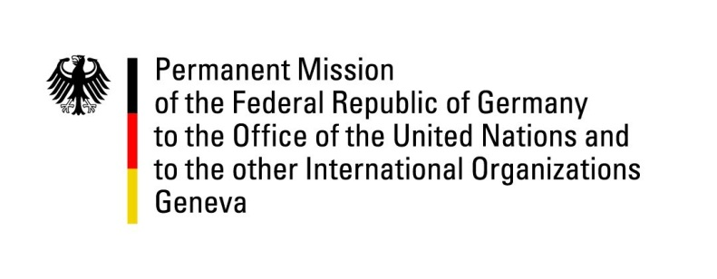

United Nations Human Rights Council

34th Session of the UPR Working Group

Geneva, 6 November 2019

Recommendations and advance questions to
San Marino

Mr. President,

Germany welcomes the achievements regarding the recognition of same-sex unions and encourages the Government of the Republic of San Marino to continue on this path. At the same time, Germany expresses its concern about persisting restrictions to sexual and reproductive health and rights, including the criminalisation of abortions.
Germany recommends:
- Sign and Ratify the Agreement on the Privileges and Immunities of the International Criminal Court.
- Ensure the full realization of sexual and reproductive health and rights, including by legalizing abortions.
- Take all necessary steps to ratify the 1951 Convention relating to the Status of Refugees and its 1967 Protocol.

Thank you, Mr. President.

GERMAN ADVANCE QUESTION TO San Marino:
- In the last UPR cycle, our recommendation regarding the ratification and full implementation of the International Convention for the Protection of All Persons from Enforced Disappearance found your support. However, to this date, the Republic of San Marino has not ratified the Convention. Could you please explain why the ratification process is still ongoing? When will the process be completed?

