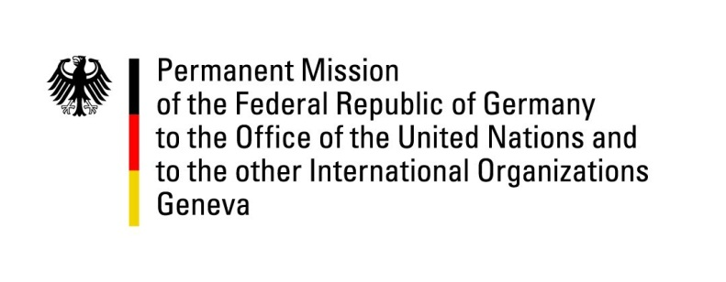

United Nations Human Rights Council

34th Session of the UPR Working Group

Geneva, 11 November 2019

Recommendations and advance questions to
Madagascar

Mr. President,

Germany welcomes the delegation of Madagascar to the third cycle of the UPR.

Germany welcomes the ratification of the Optional Protocol to the Convention against Torture and Other Cruel, Inhuman or Degrading Treatment or Punishment, and the establishment of the National Commission on Human Rights. At the same time, Germany expresses its concern about persisting restrictions on the rights of women, children and migrant workers.
Germany recommends:
- Take measures to continue the decentralization of the country.
- Implement the National Plan to Combat Human Trafficking and enforce legislation to strengthen the protection of migrant workers and prevent situations of slavery and trafficking faced by female migrant workers.
- Ensure the equal rights of women and men in all matters. Adopt legislation to criminalize all acts of violence against women and enforce legislation aimed at eliminating discrimination against women.
- Take effective measures to prevent arbitrary killings by police forces and to bring those found guilty of such actions to justice.

Thank you, Mr. President.

GERMAN ADVANCE QUESTIONS to MADAGASCAR:

- Which measures has the government taken or intends to take to prevent human trafficking and situations of slavery for migrant workers?
- Madagascar has ratified or acceded to The Second Optional Protocol to the International Covenant on Civil and Political Rights, aiming at the abolition of the death penalty and The Optional Protocol to the Convention against Torture and Other Cruel, Inhuman or Degrading Treatment or Punishment. Could you please provide information about the status of implementation and transposition of above mentioned treaties in Malagasy law?
- Despite having adopted a law on the worst forms of child labour and of the National Action Plan against Child Labour, child labour and children’s rights violations continue to be a problem in Madagascar. What further steps did the government take to address the situation?
- Could you please elaborate on the steps the government has taken or intends to take to ensure the equal rights of women and men and criminalize all acts of violence and discrimination against women? How can the government ensure measures, beyond a presidential intervention, to train the responsible authorities and decision-makers to guarantee the freedom of movement for Malagasy women in the future?
- Could you further elaborate on the measure taken to clarify allegations of arbitrary killings by police forces in 2018 and what the Government intends to undertake in order to prevent such actions in future?

