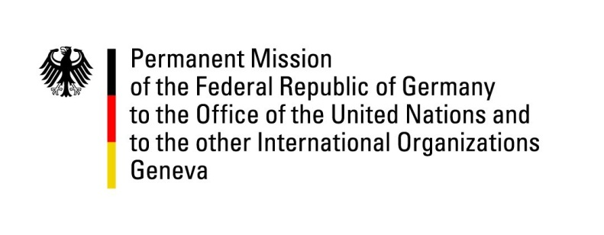

United Nations Human Rights Council

34th Session of the UPR Working Group

Geneva, 07 November 2019

Recommendations and advance questions to
Kazakhstan

Mr. President,
Germany welcomes the delegation of Kazakhstan.
We commend Kazakhstan for the efforts made in preventing and penalizing torture. In general, we have taken note of the current efforts to strengthen civil rights in Kazakhstan, and are looking forward to closely following the implementation. However, Germany remains concerned about the ongoing restriction of freedom of expression and freedom of assembly. Furthermore, we deplore the low pace of implementation of second cycle UPR recommendations.

Germany recommends to:
- Ensure freedom of expression and bring the Law on mass media, including but not limited to Art. 130 and 174 of the Criminal Code, in line with article 19 of the ICCPR and with international human rights obligations and standards.
- Repeal article 400 and 403 of the Criminal Code to guarantee the right to peaceful assembly and freedom of association for all citizens, including human rights defenders.
- Remove existing restrictions on free and democratic elections with a focus on implementing the ODIHR recommendations.
- Continue the work with regard to the Rights of the Child and the Rights of Persons with Disabilities by ratifying, without further delay, the third Optional Protocol to the Convention on the Rights of the Child and the Optional Protocol to the Convention on the Rights of Persons with Disabilities.

Thank you, Mr. President.
GERMAN ADVANCE QUESTIONS TO KAZAKHSTAN:
- During the 2nd UPR cycle, Kazakhstan supported the recommendation to extend the mandate of the Ombudsman for Human Rights in accordance with article 2 of the Paris Principles and to guarantee its independence. Which measures have been taken to fully ensure the independence of the Ombudsman?

- What concrete steps does the Government of Kazakhstan take to create an environment that guarantees freedom of expression and peaceful assembly? For example, libel and defamation are part of the Criminal Code in Kazakhstan. How does Kazakhstan ensure that these clauses and the media law are in line with international standards for freedom of expression and freedom of the press?

- Which concrete steps does Kazakhstan take in order to guarantee free and democratic elections in line with international standards, taking into account in particular the recommendations in the ODIHR election observation report?

