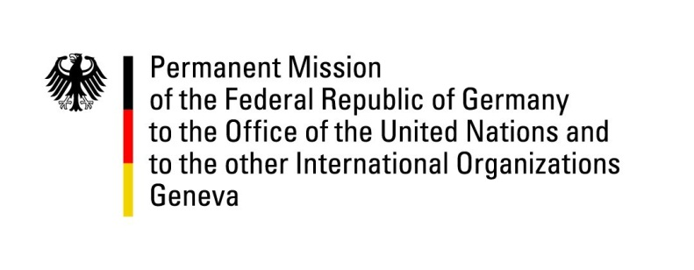

United Nations Human Rights Council

34th Session of the UPR Working Group

Geneva, 11 November 2019

German questions and recommendations to
Iraq

Thank you, Mr. President.

Germany welcomes the delegation of Iraq to the UPR.

Germany recognizes the challenges Iraq faces and welcomes initial measures addressing the causes of on-going protests. Yet we are deeply concerned by acts of violence against protesters, including the excessive use of tear gas canisters and live ammunition, which have left three hundred nineteen people dead. Germany urges the Iraqi government to take immediate steps to prevent further loss of life and encourages judicial authorities to swiftly act to hold those responsible accountable.

Germany recommends:

1. Ensure independent, transparent and impartial investigations into violence against and killings of civilians in the context of the on-going protests.
2. Reduce the number of crimes punishable by death as a first step to an overall moratorium and eventually the abolition of the death penalty.
3. Pass adequate legislation to fight and prevent domestic violence and create safe houses for women in all provinces of Iraq.
4. Grant and facilitate access to basic services such as civil documentation, welfare, healthcare and education to all Iraqi citizens regardless of the status of their security clearance and gender.

Thank you, Mr. President.

Advance questions:

- What does Iraq do to investigate violence against protesters in the wake of demonstrations that started on October 1st and what measures does the Government of Iraq intend to take to prevent the recurrence of acts of excessive violence and to further address the root causes of protests?
- Which measures has the Government of Iraq taken to improve condition in detention facilities, particularly in those, where, according to reports, minimum standards with regards to overcrowding, healthcare and the prevention of violence have not been met?
- How does Iraq counter forms of discrimination, including with regard to the rights of and compensation for women survivors of Da’esh crimes?
And in this context, what does Iraq do to improve the legal and social status of children from forced marriages of Da’esh members with women of minority groups?

