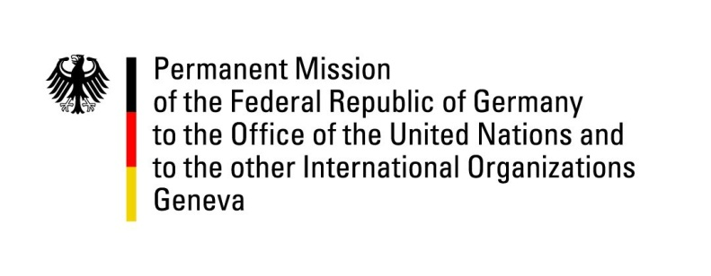

United Nations Human Rights Council

34th Session of the UPR Working Group

Geneva, 8 November 2019

German questions and recommendations to
Iran

Thank you, Mr. President.

Germany welcomes the delegation of Iran to the UPR.

Germany recognizes a decrease in executions in Iran. We also recognize the Iranian government’s continuing efforts to host a large number of Afghan refugees. Yet we remain deeply concerned by the overall human rights situation in Iran and particularly the continued use of death penalty especially sentences for and executions of juvenile offenders.

Germany recommends:

1. Cooperate fully with the United Nations human rights mechanisms, including by inviting the Special Rapporteur on the situation of human rights in Iran to the country
2. Ratify core international human rights conventions, in particular CAT and CEDAW.
3. Legislate a minimum legal age for marriage in line with CRC standards.
4. Repeal the provisions in its Penal Code which criminalize consensual same-sex activities between adults.
5. Establish a formal moratorium on the death penalty. In particular cease all planned executions of juvenile offenders and prohibit the imposition of the death penalty for crimes committed by minors.
6. Ensure the independence of the judicial system and ensure the rules of fair trial and the right to defense and access to a freely chosen lawyer.

Thank you, Mr. President.

Advance questions:

- We welcome the nationality draft law that would allow women to pass down their nationality to their children. Could you update us on the current status of the draft law? Will the law be applied retroactively?
- We welcome that Iran allowed women to be present in the station during the FIFA World Cup qualifying match in Tehran. Why are women not allowed to attend matches in the Iranian League?

