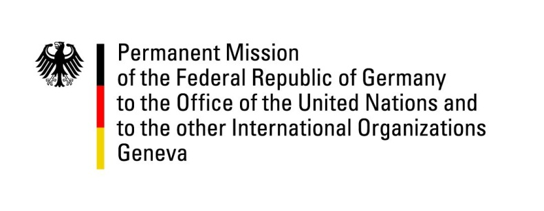

United Nations Human Rights Council

34th Session of the UPR Working Group

Geneva, 5 November 2019

Recommendations and advance questions to
The Gambia

Mr. President,

Germany welcomes the considerable progress made in the protection and application of human rights in the Gambia and acknowledges the ratification of the Optional Protocol to the Convention on the Rights of the Child on the involvement of children in armed conflict. At the same time, Germany calls for the completion of the legal reforms that have been set in motion and expresses its concern about persisting restrictions.
Germany recommends:
- Reform the Criminal Code and the Information and Communications Act to ensure that the freedom of expression and the freedom of the press are protected.
- Reform legislation on personal data protection and privacy in order to provide safeguards on the use of personal data and provide equal access to technology and communications to all citizens.
- Decriminalize same sex relationships between consenting adults and take measures to protect the human rights and the equal treatment of LGTBI persons.
- Raise awareness and enforce legislation prohibiting the practice of female genital mutilation.
- Remove the death penalty from the constitution.

Thank you, Mr. President.

GERMAN ADVANCE QUESTIONS TO Gambia:
- Could the Government of The Gambia please elaborate on the steps it has taken or intends to take with regard to legal and institutional reforms to safeguard the progress made in the field of freedom of expression, freedom of the press, freedom of assembly and the prevention of unlawful arrests and detention?
- The Gambia has ratified or acceded to the Convention against Torture and Other Cruel, Inhuman or Degrading Treatment or punishment, the Second Optional Protocol to the International Covenant on Civil and Political Rights aiming at the abolition of the death penalty, the Convention for the Protection of All Persons from Enforced Disappearance, the International Convention on the Protection of the Rights of All Migrant Workers and Members of their Families, the Convention on the Rights of Persons with Disabilities and its Optional protocol, as well as the Optional Protocol to the Convention on the Rights of the Child on the involvement of children in armed conflict. Could the Government of The Gambia please provide information about the status of implementation and transposition of above mentioned treaties in Gambian law?
- Despite having ratified CEDAW and having amended the Women’s Act 2010 to prohibit FGM in 2015, gender inequality and the practice of female genital mutilation continues to be a problem in The Gambia. What further steps did the government take to address the situation?
- Which steps has the government taken or intends to take to improve prison conditions?

