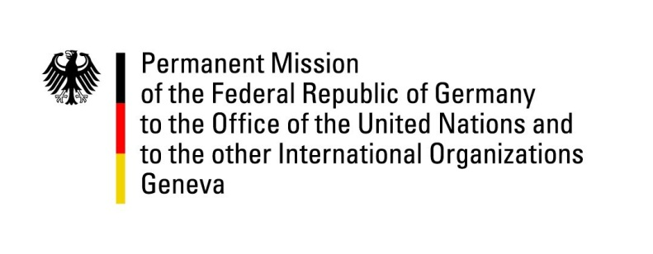

United Nations Human Rights Council

34th Session of the UPR Working Group

Geneva, 13 November 2019

Recommendations and advance questions to
Bosnia and Herzegovina

Mr. President,

Germany welcomes the delegation of Bosnia and Herzegovina to the third cycle of the UPR.

Germany acknowledges the increased institutional cooperation for the protection of LGBTI persons implemented by police agencies and the judiciary. Germany encourages the Government of Bosnia and Herzegovina to continue these efforts to prevent discrimination based on sexual orientation and gender identity.

Germany recommends:
- Take action to implement the Convention on the Rights of Persons with Disabilities, in particular the right to inclusive education.
- Implement the National Action Plan for gender equality and take action to improve women’s rights and empowerment by ensuring their meaningful participation in all political and economic processes.
- Provide justice for victims of war crimes and adopt and implement the revised national strategy on war crimes.
- Increase anti-corruption efforts by adopting and implementing legislation preventing conflicts of interest and ensuring transparent party financing in accordance with international standards.

Thank you, Mr. President.

GERMAN ADVANCE QUESTION to BOSNIA AND HERZEGOVINA:
1. What measures has Bosnia and Herzegovina taken or does it intend to take to ensure equal participation of women and compliance with statutory quotas for women in government at different levels?
2. What steps has the government of Bosnia and Herzegovina taken to ensure freedom of the press and in particular the safety of journalists, as well as the prosecution of attacks against journalists?
3. What has the government done to strengthen the capacity of the national Ombudsman and to improve the effectiveness of this office?

