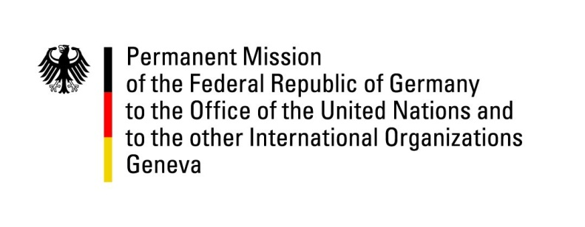

United Nations Human Rights Council

34th Session of the UPR Working Group

Geneva, 7 November 2019

Recommendations and advance questions to
Angola

Mr. President,

Germany welcomes the delegation of Angola to the UPR.

Germany welcomes the ratification of the Second Optional Protocol to the International Covenant on Civil and Political Rights aiming at the abolition of the death penalty, the Convention against Torture and Other Cruel Inhuman or Degrading Treatment or Punishment as well as the International Convention on the Elimination of All Forms of Racial Discrimination. Yet we remain deeply concerned about persisting abuse by members of security forces.
Germany recommends:
- Ratify the Rome Statute as soon as possible through the International Criminal Court.
- Join the Extractive Industries Transparency Initiative (EITI) to ensure transparency and good governance of natural resources.
- Ensure that the provisions of all international human rights treaties, to which Angola is a party, are incorporated into domestic law.
- Develop and implement a national plan to combat and prevent discrimination based on sexual orientation and gender identity;

Thank you, Mr. President.

