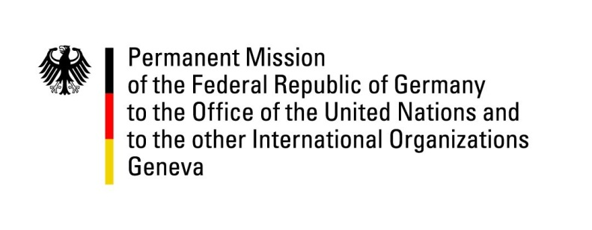

United Nations Human Rights Council

34th Session of the UPR Working Group

Geneva, 13 November 2019

Recommendations and advance questions to
Egypt

Mr. President,

Germany welcomes the acquittal of foreign NGO workers and encourages the Government of Egypt lift travel bans and asset freezes of Egyptian NGO workers. Germany is concerned by ongoing human rights violations, including in the context of the latest protests.
Germany recommends:
1. Restrict the excessive use of pre-trial detention and police probation measures to the narrow limits outlined in Article 54 of the Constitution.
2. Guarantee the rights of prisoners to regular family visits, medical treatment and access to lawyers, including in high-security prisons.
3. Stop restricting and criminalizing the work of human rights defenders, politicians and civil society actors.
4. Guarantee freedom of expression and press online and offline by revising laws 175 and 180 of 2018 and the Penal Code.
5. Take action to improve women’s rights by criminalizing domestic violence and amending the Personal Status Law.

Thank you, Mr. President.

