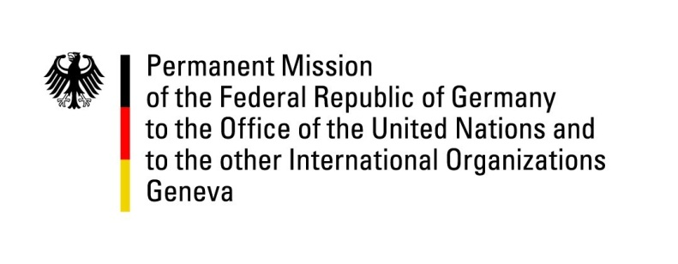

United Nations Human Rights Council

34th Session of the UPR Working Group

Geneva, 5 November 2019

German questions and recommendations to
Bolivia

Thank you, Mr. President.

Germany welcomes the delegation of Bolivia to the UPR and recognizes the progress Bolivia has made with regard to providing access to safe water and sanitation.

Germany recommends:

- Initiate a comprehensive set of measures to address existing inefficiencies within the judicial system including ensuring efficient prosecution and crime prevention while guaranteeing judicial independence, including that of the constitutional court.
- Eliminate the requirement of filing a complaint to access the Legal Interruption of Pregnancy (ILE) in case of rape and amend the criminal regulations to decriminalize women and girls in cases of abortion.
- Develop a legal framework that recognizes the Right to Form a Family between people of the same sex, granting the same rights conferred to couples of different sexes through marriage and free unions in accordance with the provisions of Constitutional Order 0028/17.
- Ensure the right to consultation and to free and informed consent of Indigenous Peoples on projects that may affect them, in line with ILO Convention 169, the UN Declaration on the Rights of Indigenous Peoples and the jurisprudence of the Inter-American Court of Human Rights;

Thank you, Mr. President.

Advance questions:

- What specific plans and resources are available to assist indigenous people severely affected by exploitation of natural resources in the cases of Jach´a Marka Tapacarí Condor Apacheta, Choquecota Marka del Suyu Jacha´a Carangas, Marca Quila Quila, Takana II and Takovo Moro II?
- What protection measures have been adopted in order to guarantee the safety of NGOs that criticize governmental public policies?
- Are there any plans to introduce comprehensive legislation on pollution caused by heavy metals since the levels of mercury emissions from mining activities are increasing?
- How will the Government of Bolivia guarantee women better access to government services, particularly in rural areas? What further measures are taken by the Bolivian government to improve women`s education on their rights?
- What specific measures will the Government of Bolivia take to reduce discrimination against LGBTIs, indigenous peoples and other minorities? How is the Bolivian Government dealing with widespread impunity in cases of violence against these minorities?

