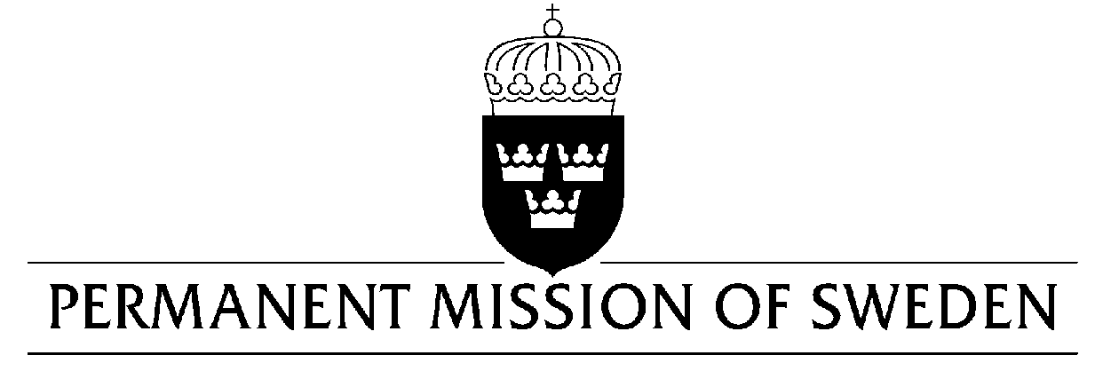
UN Human Rights Council

UPR 34rd session

Statement by Sweden in the interactive dialogue on Bosnia and Herzegovina

Delivered by Ambassador Veronika Bard
Geneva, 13 November 2019 (speaking time 1, 35 min, speaker no. 63)

Mr President,

Sweden welcomes the delegation from Bosnia and Herzegovina and progress made in certain areas of human rights, such as amendments to the antidiscrimination law in 2016. However, Sweden remains concerned in particular by the lack of amendment of the electoral law, about media freedom, and by widespread corruption. Sweden would therefore like to make the following recommendations:

- To ensure that the electoral law is amended to promote the representation of women at different levels of government.

- To guarantee a free and independent media and to promote an open and democratic media landscape in respect of freedom of opinion and expression as well as the right to access information.

- To ensure that the relevant institutions tasked with fighting corruption are independent and adequately resourced.

Sweden wishes Bosnia and Herzegovina all success in the current review.

I thank you Mr President.

