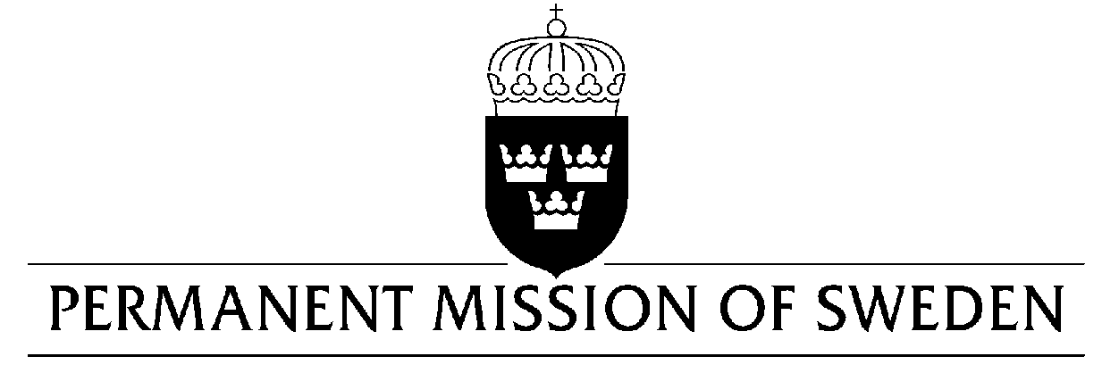
UN Human Rights Council

UPR 34rd session

Statement by Sweden in the interactive dialogue on Egypt

Delivered by Ambassador Veronika Bard
Geneva, 13 November 2019 (speaking time 0,55 min, speaker no. 35)

Mr President,

Sweden welcomes the Egyptian delegation. Sweden acknowledges some improvements regarding the political participation of women. However, the human rights situation is still a cause of concern and further efforts are needed, including for women’s and girl’s full enjoyment of human rights. Sweden also sees a worrying development of shrinking space for civil society. Sweden would therefore like to make the following recommendations:

- To stop unduly restricting space for civil society, including through assets freezes, travel bans, long periods of pre-trial detention and a growing number of arrests.

- To ratify the Optional Protocol to the Convention against Torture.

- To review the personal status legislation and the Penal Code in order to further modify or delete articles that discriminate against women, including by lifting the reservation on article 16 of CEDAW.

Sweden wishes Egypt all success in the current review.

I thank you Mr President.

