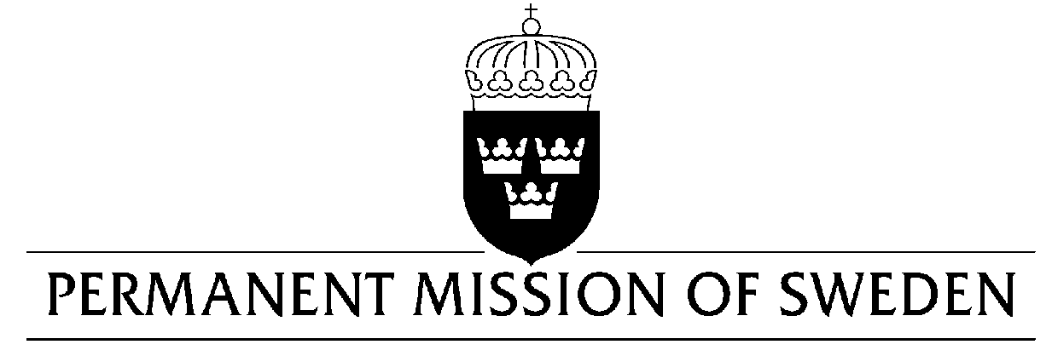
UN Human Rights Council

UPR 34rd session

Statement by Sweden in the interactive dialogue on Iraq

Delivered by Ambassador Veronika Bard
Geneva, 11 November 2019 (speaking time 1, 05 min, speaker no. 18)

Mr President,
Sweden welcomes the Iraqi delegation. Since Iraq’s last UPR, we have seen the rise and, largely fall of Daesh. Sweden acknowledges efforts made to bring about stability, but continues to be concerned by the human rights situation, including in recent demonstrations. We urge the government to guarantee the rights to peaceful assembly and freedom of expression.
Sweden would like to make the following recommendations:

- To immediately introduce a moratorium on the death penalty, as a first step toward its abolition.
- To enact a law that prohibits and provides penalties for international crimes including genocide, war crimes and crimes against humanity.

- To work with international partners, such as UNITAD, to bring charges against those who have committed genocide, war crimes and crimes against humanity.

- To increase efforts to combat sexual and gender-based violence, in line with the National Strategy, including criminalizing domestic violence.

- To enhance efforts to combat corruption, in full accordance with international law, to ensure equal access to public services.

Sweden wishes Iraq all success in the current review.

I thank you Mr President.

