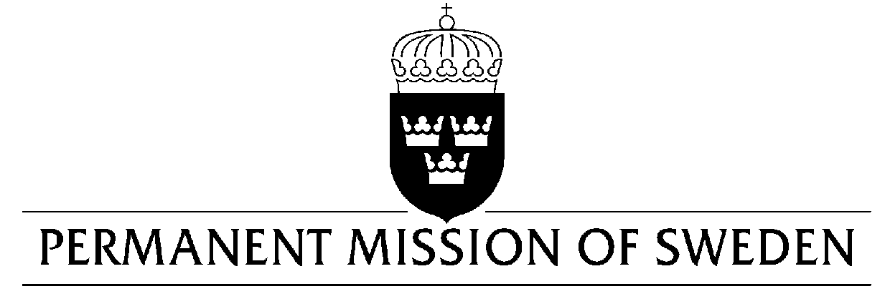
UN Human Rights Council

UPR 34rd session

Statement by Sweden in the interactive dialogue on Iran

Delivered by Ambassador Mikael Anzén
Geneva, 8 November 2019 (speaking time 1, 05 min, speaker no. X)

Mr President,

Sweden welcomes the delegation of Iran. Sweden remains seriously concerned about a number of human rights issues in Iran, including the situation for women and girls, while welcoming a significant decrease in the number of executions due to a reduction of executions for drug-related offences. Sweden would like to make the following recommendations:

- To fully cooperate with and grant immediate and unfettered access for the Special Rapporteur on the situation of Human Rights in Iran.

- To immediately introduce a moratorium on the death penalty, including for juvenile offenders, as a first step towards abolition.

- To take urgent action to improve the protection of human rights defenders, including those defending women’s and girls’ full enjoyment of human rights.

Sweden wishes Iran all success in the current review.

I thank you Mr President.

