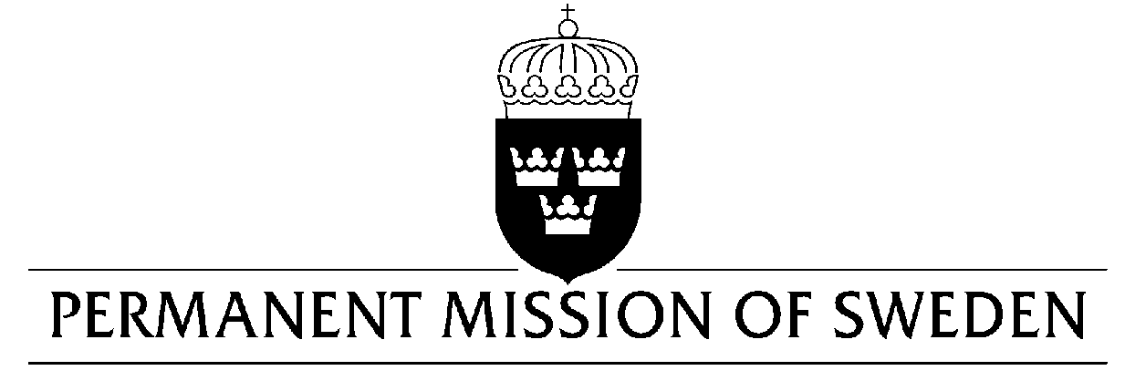
UN Human Rights Council

UPR 34rd session

Statement by Sweden in the interactive dialogue on Angola

Delivered by Minister Counsellor Karin Bolin
Geneva, 7 November 2019 (speaking time 1,05 min, speaker no. 113)

Mr President,

Sweden welcomes the Angolan delegation and acknowledges the steps taken to strengthen human rights. This includes revision of the Penal Code, the launching of a human rights strategy, and the recent ratification of three important conventions. However, Sweden remains concerned that these efforts have not yet been translated into practice. These concerns are compounded by a failure to systematically hold perpetrators of human rights violations to account. Sweden would therefore like to make the following recommendations:

- To take concrete measures, including allocation of sufficient funds, to ensure access to adequate healthcare for all, including women and those in vulnerable situations such as poor persons, children and migrants.
- To ensure that necessary legal and institutional mechanisms are in place to prevent and punish all forms of violence against women and girls.
- To fulfil the right to freedom of expression, as accepted in the last review cycle, including by taking effective measures to ensure that journalists are protected against all forms of violence, harassment and arbitrary deprivation of liberty.

Sweden wishes Angola all success in the current review.

I thank you Mr President.

