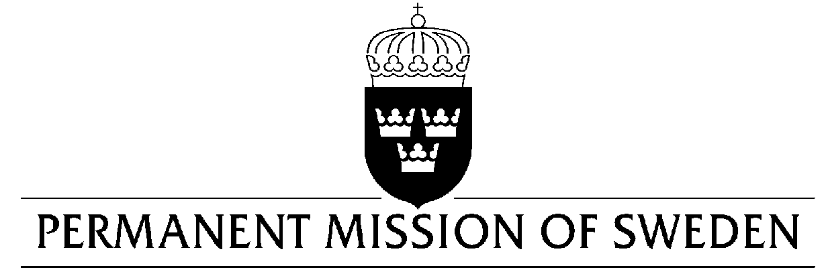
UN Human Rights Council

UPR 34rd session

Statement by Sweden in the interactive dialogue on Kazakhstan

Delivered by Minister Counsellor Karin Bolin
Geneva, 7 November 2019 (speaking time 1, 15 min, speaker no. 93)

Mr President,

Sweden welcomes the delegation of Kazakhstan. Sweden takes note of remarks made by the President on 2 September on the need to improve legislation on the human right to freedom of peaceful assembly and welcomes this important issue to be thoroughly addressed. Sweden would like to encourage further efforts to protect women and LGBTI persons, and all persons in vulnerable situations, from violence and discrimination, as well as a complete abolishment of the death penalty. Sweden would therefore like to make the following recommendations:

- To make necessary amendments to the Criminal code to ensure that perpetrators of crimes of sexual violence do not enjoy impunity based on so called “reconciliation“ with the victim.

- To abolish the death penalty completely.

- To adopt a comprehensive anti-discrimination legislation which includes sexual orientation and gender identity as protection grounds.

Sweden wishes Kazakhstan all success in the current review.

I thank you Mr President.

