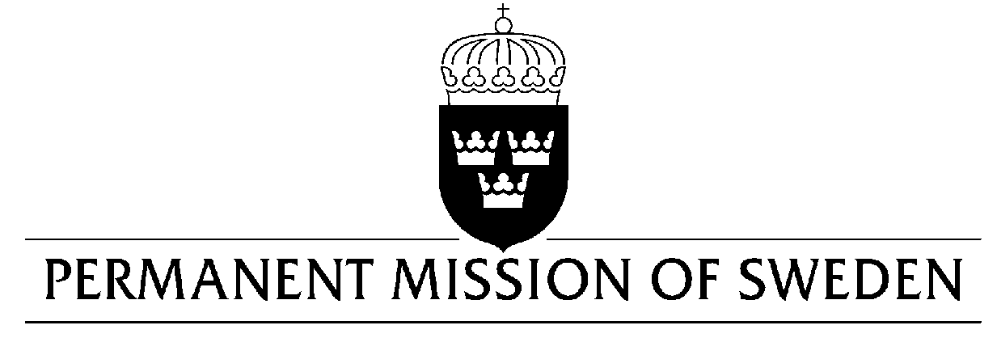
UN Human Rights Council

UPR 34rd session

Statement by Sweden in the interactive dialogue on Bolivia

Delivered by Minister Counsellor Karin Bolin
Geneva, 5 November 2019 (speaking time 1,20 min, speaker no.21)

Mr President,
Sweden welcomes the delegation of Bolivia and important advances made in the area of poverty reduction during the last 15 years. Sweden further acknowledges the government’s commitment to strengthen the rights and political participation of women and persons in vulnerable situations, not least indigenous peoples. However, further efforts are needed to ensure the respect, protection and fulfillment of human rights in several areas. Sweden would therefore like to make the following recommendations:

- To amend legal requirements, in particular law 351 and Supreme decree 1597, that restrict the rights of civil society to peaceful assembly and association.

- To ensure that human rights and environmental rights defenders, including those critical towards government policies and views, can pursue their activities without intimidation.

- To take decisive action to respect, protect and fulfill the right to a healthy and sustainable environment including in areas such as water management, safeguarding of natural resources, and the protection of natural reserves.

- To ensure the financial, legal and other resources necessary to combat prison overcrowding, judicial backlogs and long periods of pre-trial detention.

Sweden wishes Bolivia all success in the current review.

I thank you Mr President.

