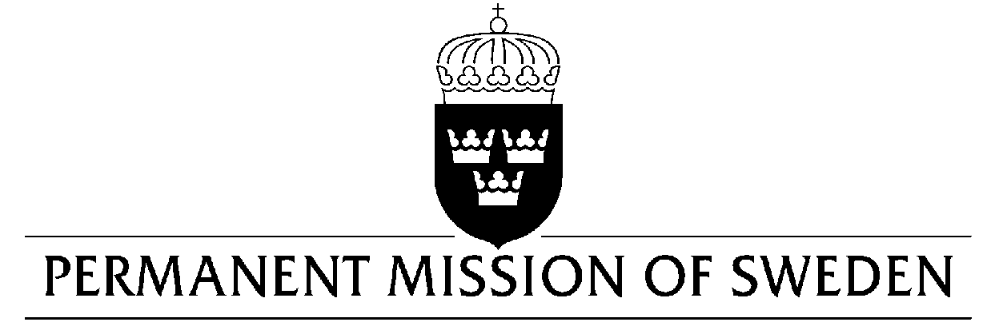
UN Human Rights Council

UPR 34rd session

Statement by Sweden in the interactive dialogue on El Salvador

Delivered by Ambassador Mikael Anzén
Geneva, 4 November 2019 (speaking time 1,35 min, speaker no. 46)

Mr President,

Sweden welcomes the delegation of El Salvador and the pledge made by President Bukeles to create an interministerial roundtable to discuss how to improve the human rights situation in the country. Sweden also welcomes the Government’s ambition to become a strong regional voice on human rights including its commitment to condemn human rights violations in the region. However, continued efforts are needed to ensure sexual and reproductive health and rights of women and girls. Sweden would therefore like to make the following recommendations:

- To guarantee access to safe and legal abortion, by repealing laws criminalizing abortion as a first step.

- To end the unjust imprisonment of women who have had obstetric emergencies.

- To take concrete steps to guarantee the full enjoyment of sexual and reproductive health and rights of all women and girls.

Sweden wishes El Salvador all success in the current review.

I thank you Mr President.

