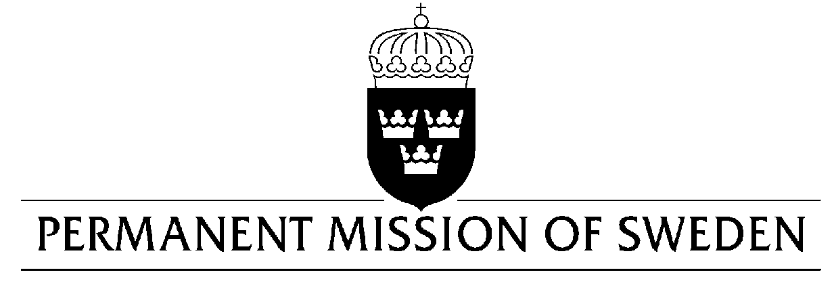
UN Human Rights Council

UPR 34rd session

Statement by Sweden in the interactive dialogue on Italy

Delivered by Minister Counsellor Karin Bolin
Geneva, 4 November 2019 (speaking time 1 min, speaker no.111)

Mr President,

Sweden welcomes the Italian delegation and efforts made to address recommendations made during the previous cycle, including steps to align national legislation with the Rome Statute of ICC. However, further efforts with regard to racism and racial discrimination, as well as increasing the efficacy of the judicial system and the fight against corruption are needed. Sweden would therefore like to make the following recommendations:

- To take necessary legal and policy measures, in accordance with international law, to effectively counter racism and discrimination due to ethnic origin against any specific group.

- To adopt measures, such as strengthening institutions and addressing inefficiencies, to increase the effectiveness of the judicial system.

- To adopt effective measures, including supporting the Anticorruption Authority, to address and prevent corruption.

Sweden wishes Italy all success in the current review.

I thank you Mr President.

