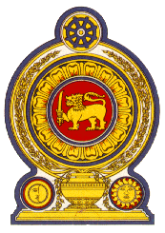

Statement by the Democratic Socialist Republic of Sri Lanka
34th Session of the Universal Periodic Review

Review of Kazakhstan– 7th November 2019

Sri Lanka warmly welcomes the delegation of Kazakhstan and appreciates the detailed presentation made.

Sri Lanka takes note of the reforms undertaken by Kazakhstan to its constitution in 2017 and the adoption of amendments to the laws on elections, aimed at developing a multi-party system, including the introduction of a proportional system of elections for representatives of local authorities.

We take positive note that Kazakhstan since its last UPR has ratified the Convention on the Rights of Persons with Disabilities and there is current movement towards the ratification of the Optional Protocol to the International Covenant on Economic, Social and Cultural Rights. We also note Kazakhstan’s commitment to zero tolerance of torture and violence, especially against women and children.

In a constructive spirit, Sri Lanka recommends that Kazakhstan:

- Ratifies the International Convention on the Protection of the Rights of All Migrant Workers and Members of Their Families and continues to promote measures to protect and promote the rights of migrant workers;
- Further enhances participation of women in decision-making roles in political, economic and social spheres of life ; and
- Continues to engage with the UN human rights mechanisms, including the special procedures.

We wish Kazakhstan success in its UPR engagement.

