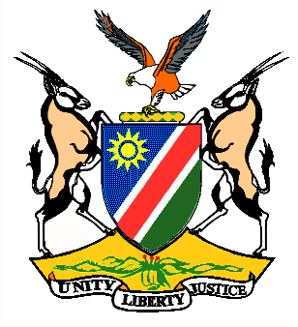

Statement by H.E. Penda A. Naanda, Ambassador/PR, Dialogue on the Universal Periodic Review of the Republic of Angola 07 November 2019

- Thank you, Mr. President,

- Namibia warmly welcomes H.E. Mr. Manuel Domingos Augusto, Minister of External Relations of the Republic Angola and his delegation to the 3rd cycle of the UPR and congratulate them for presenting a comprehensive national report.

- Notwithstanding the challenges highlighted in the Report, Namibia commends the Government of the Republic of Angola for the positive human rights impact measures taken over the years, which in our view clearly demonstrates Angola’s resolute commitment to advance and protect universally recognised human rights. We welcome the ratification by Angola on 02 October 2019 of four major International Human Rights Treaties.

- In the spirit of constructive engagement, we recommend the following to Angola for consideration:

  - Completely eliminate child, early and forced marriage by amending the Family Code of 1988.

  - Put in place an awareness raising programme for all stakeholders on Women Rights.

- We encourage Angola to continue with its engagement and cooperation with the International Community in the quest to further improve the state of Human Rights in Angola.

- Namibia wishes the delegation of Angola a successful review.

- I thank you Mr. President.

