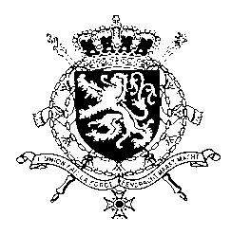
Représentation permanente de la Belgique auprès des Nations Unies et auprès des institutions spécialisées à Genève

WG UPR 34 – Kazakhstan
Belgian intervention
7th of November 2019

Mr. President,

Belgium welcomes the delegation of Kazakhstan and wishes it every success in the exercise of its third Universal Periodic Review. Belgium is convinced that – especially in view of the recent transition of power - further progress can be achieved to increase the protection of human rights in line with the core international human rights treaties.

Therefore, we would like to formulate the following recommendations:

R1. Amend the article on ‘Violations of the Equality of People and Citizens’ (article 145) of the Criminal Code to explicitly and separately include ‘sexual orientation’ and ‘gender identity’ as protected characteristics.

R2. Amend article 174 of the Criminal Code, on ‘incitement of social, clan, national, racial or religious discord’, notably through a narrow well-defined interpretation of ‘discord’, to prevent arbitrary prosecutions.

As Belgium attaches great importance to freedom of expression and assembly, we recommend Kazakhstan to:

R3. Review the public assembly law to bring it in line with the International Covenant on Civil and Political Rights.

Thank you, Mr. President.

