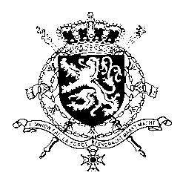
Représentation permanente de la Belgique auprès des Nations Unies et auprès des institutions spécialisées à Genève

WG UPR – Iraq
Belgian intervention
11th November 2019

Mr. President,

Belgium welcomes the delegation of Iraq and wishes it every success in the exercise of its third UPR. We would like to express our solidarity with the Iraqi people, who are still facing the terrible consequences of the fight against Da’esh on a daily basis. The human rights challenges in the aftermath of the conflict require sustained efforts. Against this background, we would like to formulate the following recommendations:

R1. Put a strategy in place preventing the risk of discrimination, stigmatization and marginalization of internally displaced women and children with alleged Daesh affiliation and creating the necessary conditions for their successful reintegration into Iraqi society

R2. Adopt the draft law on domestic violence in line with international standards, thus excluding the possibility for the perpetrator of a rape to marry the victim.

R3. Ensure full respect for all fair trial and due process guarantees enshrined in Article 14 of the International Covenant on Civil and Political Rights.

As a strong opponent of the death penalty, Belgium reiterates its recommendation of the previous UPR:

R4. Abolish the death penalty, and in an intermediate phase, adopt an immediate moratorium on executions.

Thank you, Mr. President.

