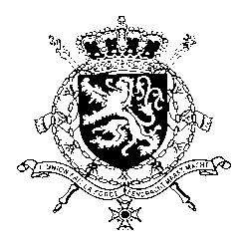
Représentation permanente de la Belgique auprès des Nations Unies et auprès des institutions spécialisées à Genève

WG UPR – Egypt
Belgian intervention
13th November 2019

Mr. President,

Belgium welcomes the delegation of Egypt and wishes it every success in the exercise of its third UPR. While taking note of certain steps taken by Egypt since its previous UPR, we are concerned about the shrinking space for civil society and an increasing resort to the death penalty, also in the context of mass trials.

Therefore, we would like to formulate the following recommendations:

R1. Repeal all laws and policies that restrict the activities and rights of human rights defenders, such as Law no. 70/2017, Counter-terrorism law no. 94, Article 78 of the Penal Code, the Anti-Cyber and Information Technology Crimes Law, and the Media Regulation Law.

R2. Conduct investigations, in accordance with international standards, into excessive violence committed by military and security forces during demonstrations and bringing those responsible to justice.

As a strong opponent of the death penalty, Belgium further recommends at least to

R3. Amend article 22 of the Child Law to prevent those who were children at the time of the alleged offence from being tried on capital offences alongside adults.

Thank you, Mr. President.

