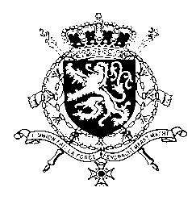
Représentation permanente de la Belgique auprès des Nations Unies et auprès des institutions spécialisées à Genève

WG UPR – Bolivia
Belgian intervention
5th November 2019

Mr. President,

Belgium welcomes the delegation of Bolivia and wishes it every success in the exercise of its third Universal Periodic Review. We acknowledge the progress made by Bolivia since its previous UPR. However, Belgium is convinced that further progress can still be achieved to increase the protection of human rights in line with the core international human rights treaties.

Therefore, we would like to formulate the following recommendations:

R1. Take further measures to implement existing legislation that guarantees sexual and reproductive health and rights for women and girls.

R2. Set up government policies that create a safe and respectful environment for the work of human rights defenders, especially women human rights defenders and environmental defenders.

In line with its recommendation during the previous UPR, Belgium recommends the government of Bolivia to:

R3. Continue to take the necessary measures to fully eradicate child labour, without exception, in accordance with ILO Convention No. 138, ratified by Bolivia.

Thank you, Mr. President.

