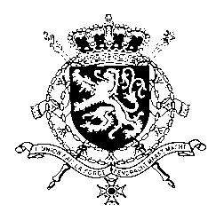
Représentation permanente de la Belgique auprès des Nations Unies et auprès des institutions spécialisées à Genève

WG UPR – Angola
Belgian intervention
7th November 2019

Mr. President,

Belgium welcomes the delegation of Angola and wishes it every success in the exercise of its third Universal Periodic Review. We acknowledge the progress made by Angola since its previous UPR and especially welcome Angola’s recent ratification of the Second Optional Protocol to the International Covenant on Civil and Political Rights, aiming at the abolition of the death penalty.

However, Belgium is convinced that further progress can still be achieved to increase the protection of human rights in line with the core international human rights treaties. Therefore, we would like to formulate the following recommendations:

R1. Protect the freedom of expression by ensuring that all provisions of the Press Law are brought into conformity with article 19 of the International Covenant on Civil and Political Rights.

R2. Increase the minimum age for marriage to 18 years for both boys and girls without exceptions, and criminalize all forms of forced and child marriage.

R3. Intensify efforts to ensure universal access to free and compulsory quality education for children.

Thank you, Mr. President.

