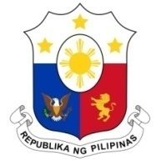
PHILIPPINES

Human Rights Council
34th Session of the Working Group on the Universal Periodic Review
04 November 2019, Salle XX, Palais des Nations

ITALY

Speaking Time: 1 minute
Speaking Order: 91 of 124

Thank you, Mr. President.

The Philippines warmly welcomes the delegation of Italy.

My delegation recognizes Italy’s efforts to further protect the rights especially of women, children, and other vulnerable groups.

In a constructive spirit, the Philippines presents the following recommendations:

- Continue to review and assess its immigration laws and policies to ensure that the rights of migrants are fully safeguarded, in accordance with international human rights standards;

- Ensure that anti-trafficking programs are responsive to women and girl victims especially in the context of recent migration flows;

- Ensure that the implementation and assessment of the National Strategic Plan on male violence against women 2017 to 2020 incorporate the views and recommendations of the women victims of violence.

- Step up its efforts in combating racism and xenophobia through education, training, and awareness-raising programs
We wish Italy every success in this review cycle.
Thank you, Mr. President.

