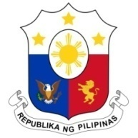
PHILIPPINES

Human Rights Council
34th Session of the Working Group on the Universal Periodic Review
11 November 2019, Salle XX, Palais des Nations

IRAQ

Speaking Time: 1 min 5 sec.
Speaking Order: 112 of 113

Thank you, Madam Vice-President.

The Philippines warmly welcomes the delegation of Iraq to this UPR session.

My delegation continues to be encouraged by the constructive approach of Iraq to the UPR process. We laud Iraq for the adoption of a number of measures in the areas of poverty reduction, health, and combating violence against women.

In a constructive spirit, the Philippines presents the following recommendations for consideration:

- Continue supporting the work of its National Human Rights Institution;

- Continue strengthening efforts in training and capacity-building programs for duty bearers on combating trafficking in persons, especially women and children; and

- Ensure the allocation of sufficient resources for the effective implementation of its development and poverty reduction plans and strategies.

We wish Iraq every success in this review cycle.

Thank you, Madam Vice-President. END.

