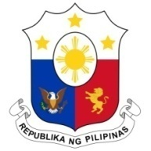
PHILIPPINES

Human Rights Council
34th Session of the Working Group on the Universal Periodic Review
08 November 2019, Salle XX, Palais des Nations

IRAN

Speaking Time: 1 min 5 sec
Speaking Order: 106 of 114

Thank you, Mr. President.

The Philippines warmly welcomes the distinguished delegation of Iran to this UPR session.

We acknowledge the constructive approach of Iran to the UPR process. We are pleased to note its adoption of a number of laws aimed at further advancing the protection of women and persons with disabilities.

We welcome Iran’s committed efforts to ensure universal access to education, with emphasis on the education of girls and vulnerable groups.

In a constructive spirit, the Philippines presents the following recommendations for consideration by Iran:

- Continue its efforts in the field of human rights capacity-building and training for duty bearers;

- Further strengthen measures to support the economic participation women; and

- Consider the conduct of periodic review and assessment of its disaster risk reduction management and climate change adaptation efforts with due consideration to the protection of most vulnerable sectors of society.

We wish Iran every success in this review cycle.

Thank you, Mr. President. END.

