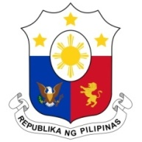
PHILIPPINES

Human Rights Council
34th Session of the Working Group on the Universal Periodic Review
06 November 2019, Salle XX, Palais des Nations

FIJI

Speaking Time: 12 of 98
Speaking Order: 1 min. 15 sec.

Thank you, Mister President.

The Philippines warmly welcomes the delegation of Fiji to this UPR session.

My delegation acknowledges the significant progress made by Fiji in implementing the accepted recommendations during the second UPR cycle. In particular, the Philippines commends Fiji for completing the process of ratification of all nine core human rights treaties and conventions during the period 2014-2019.

In a constructive spirit, the Philippines presents the following recommendations for consideration by Fiji:

- Further intensify awareness-raising programs for vulnerable groups on the National Climate Change and National Disaster Risk Reduction Policies to ensure their inclusive implementation;

- Continue to strengthen policies and program to address discrimination and violence against women; and

- Consider the ratification of the ILO Domestic Workers Convention no. 189.

We wish Fiji every success in this review cycle.

Thank you, Mister President. END

