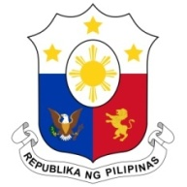
PHILIPPINES

Human Rights Council
34th Session of the Working Group on the Universal Periodic Review
13 November 2019, Salle XX, Palais des Nations

EGYPT

Speaking Time: 55 sec.
Speaking Order: 16 of 136

Thank you, Mister President.

The Philippines warmly welcomes the delegation of Egypt to this UPR session.

My delegation acknowledges the inclusive process undertaken by Egypt in the preparation of its national report and efforts to further institutionalize human rights.

We welcome the progress made particularly in the areas of empowerment of women, anti-trafficking, and advancing the protection of the human rights of vulnerable sectors.

In a constructive spirit, the Philippines presents the following recommendations for consideration by Egypt:

- Continue its efforts in conducting awareness-raising campaigns on the human rights of women and girls;

- Further strengthen capacity-building activities and provision of support for women in micro, small and medium enterprises; and

- Continue efforts to reduce poverty, in particular in rural and underdeveloped areas.

We wish Egypt every success in this review cycle.

Thank you, Mister President. END

