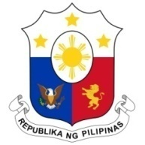
PHILIPPINES

Human Rights Council
34th Session of the Working Group on the Universal Periodic Review
07 November 2019, Salle XX, Palais des Nations

ANGOLA

Speaking Time: 1 min 5 sec
Speaking Order: 96 of 116

Thank you, Mr. President.

The Philippines warmly welcomes the distinguished delegation of Angola to this UPR session.

We acknowledge Angola’s strong commitment to the promotion and protection of human rights and commend its development of the National Human Rights Strategy for 2019–2022.

We recognize Angola’s adoption of robust policy measures and programs to advance the rights of women and children and ensure their protection.

In a constructive spirit, the Philippines presents the following recommendations for consideration by Angola:

- Continue to strengthen the implementation of policies and programs on advancing the rights of women, children, persons with disabilities, and other vulnerable sectors; and

- Further intensify efforts in human rights education and training for duty bearers and the public.

We wish Angola every success in this review cycle.

Thank you, Mr. President. END

