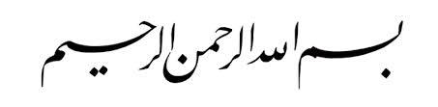

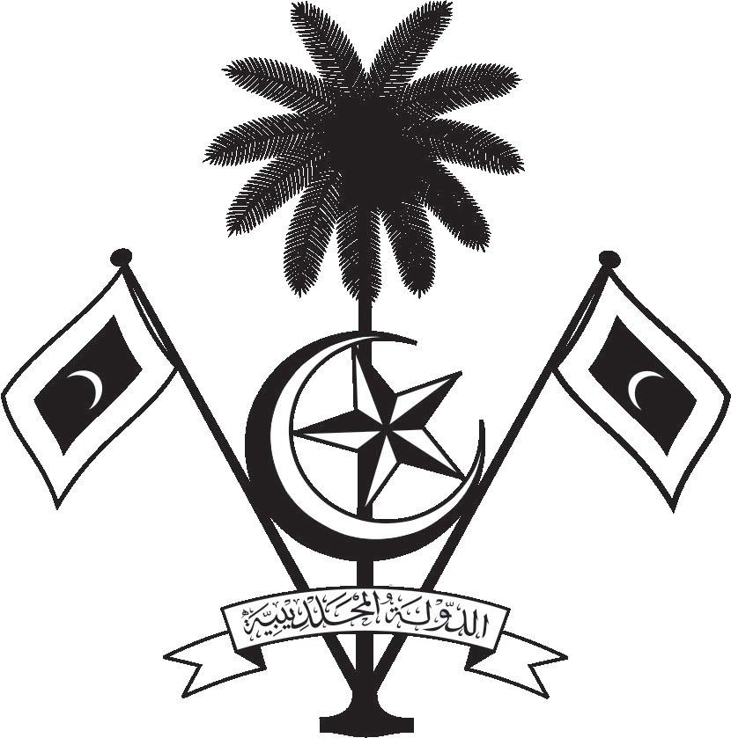

އ.ދ.ގެ ޖެނީވާ އޮފީހާއި ޖެނީވާގައި ހުންނަ ބައިނަލްއަޤްވާމީ ޖަމިއްޔާތަކަށް ކަނޑައަޅާފައިވާ ދިވެހިރާއްޖޭގެ ދާއިމީ މިޝަން
PERMANENT MISSION OF THE REPUBLIC OF MALDIVES TO THE UNITED NATIONS OFFICE
AND OTHER INTERNATIONAL ORGANISATIONS AT GENEVA
34th Session of the Working Group of the Universal Periodic Review
4-15 November 2019, Geneva

Review of Egypt
13 November 2019

Statement by:
Ambassador Hala Hameed

Check against delivery
Thank you, Mr. President,

The Maldives warmly welcomes the high-level delegation of the Arab Republic of Egypt to this third cycle review and thanks the delegation for their presentation today.

In constructive spirit, the Maldives presents the following two recommendations to Egypt:

- Continue to develop interventions to support youth access to decent jobs, and promote social integration of youth in urban and rural areas to reduce youth unemployment.

- Expand the reproductive health and family planning programmes to reach the rural areas and introduce integrated reproductive health package for women.

We commend Egypt on the constitutional amendments of April 2019 allocating 25 per cent of seats in both the Parliament and local councils to women.

We wish Egypt every success at this Review.
Thank you, Mr. President.

