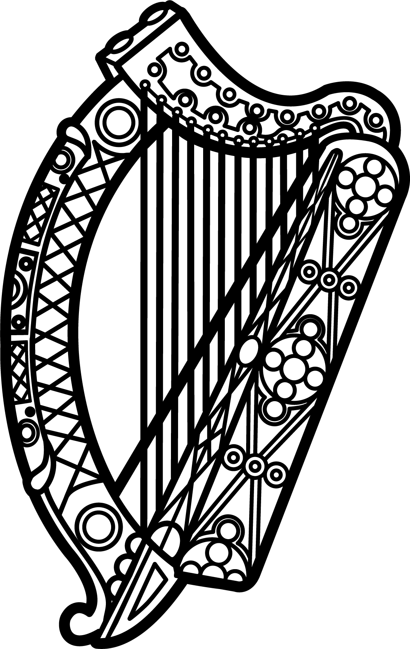

Statement of Ireland
34th session of the UPR Working Group

Review of the Republic of Slovenia

12 November 2019

Thank you, Mr President.

Ireland warmly welcomes the delegation of the Republic of Slovenia and thanks them for their presentation. We commend the Republic of Slovenia for the leadership shown on human rights issues, including during its recent membership of the Human Rights Council.

Ireland acknowledges the efforts of the Republic of Slovenia to advance human rights domestically and welcomes the positive progress made since the last UPR cycle. We welcome in particular the introduction in 2017 of legislation broadening the powers of the institution of the Human Rights Ombudsman. We also welcome the launch of the National Action Plan on Business and Human Rights in 2018 and encourage its full implementation.

Ireland also commends the Republic of Slovenia for ratifying the Istanbul Convention and the Optional Protocol to the Convention on the Rights of the Child on a communication procedure.

Ireland makes the following recommendations to the Slovenian authorities:

- Ensure that the Ombudsman and other national human rights mechanisms are adequately funded and that financial control is fully independent of government.

- Intensify efforts to combat stereotypes and prejudice against LGBTI persons, including by launching a nationwide awareness-raising campaign.

We wish the Republic of Slovenia every success with this UPR cycle.

Thank you.

