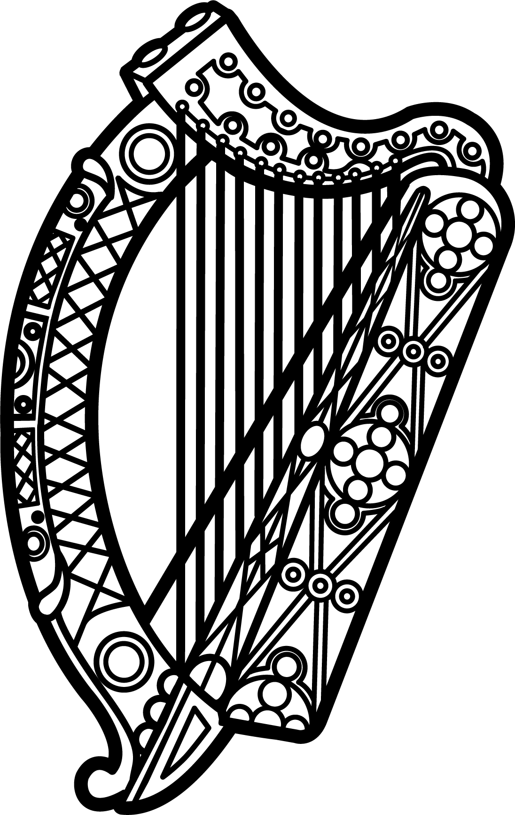

Statement of Ireland
34th session of the UPR Working Group

Review of San Marino

6 November 2019

Thank you, Mr (Vice) President.

Ireland warmly welcomes the delegation of San Marino and thanks them for their presentation.

Ireland acknowledges San Marino’s efforts to advance human rights domestically and welcomes progress made since the last UPR cycle. In particular, Ireland commends San Marino for signing, ratifying and acceding to a number of international and regional human rights instruments, including the Optional Protocol to the Convention on the Rights of the Child on a communications procedure in 2018.

Ireland makes the following recommendations to the San Marino authorities:

- Establish a National Human Rights Institution (NHRI), in accordance with the Paris Principles

- Submit all outstanding reports to the treaty bodies as soon as possible

We wish San Marino every success with this UPR cycle.

Thank you.

