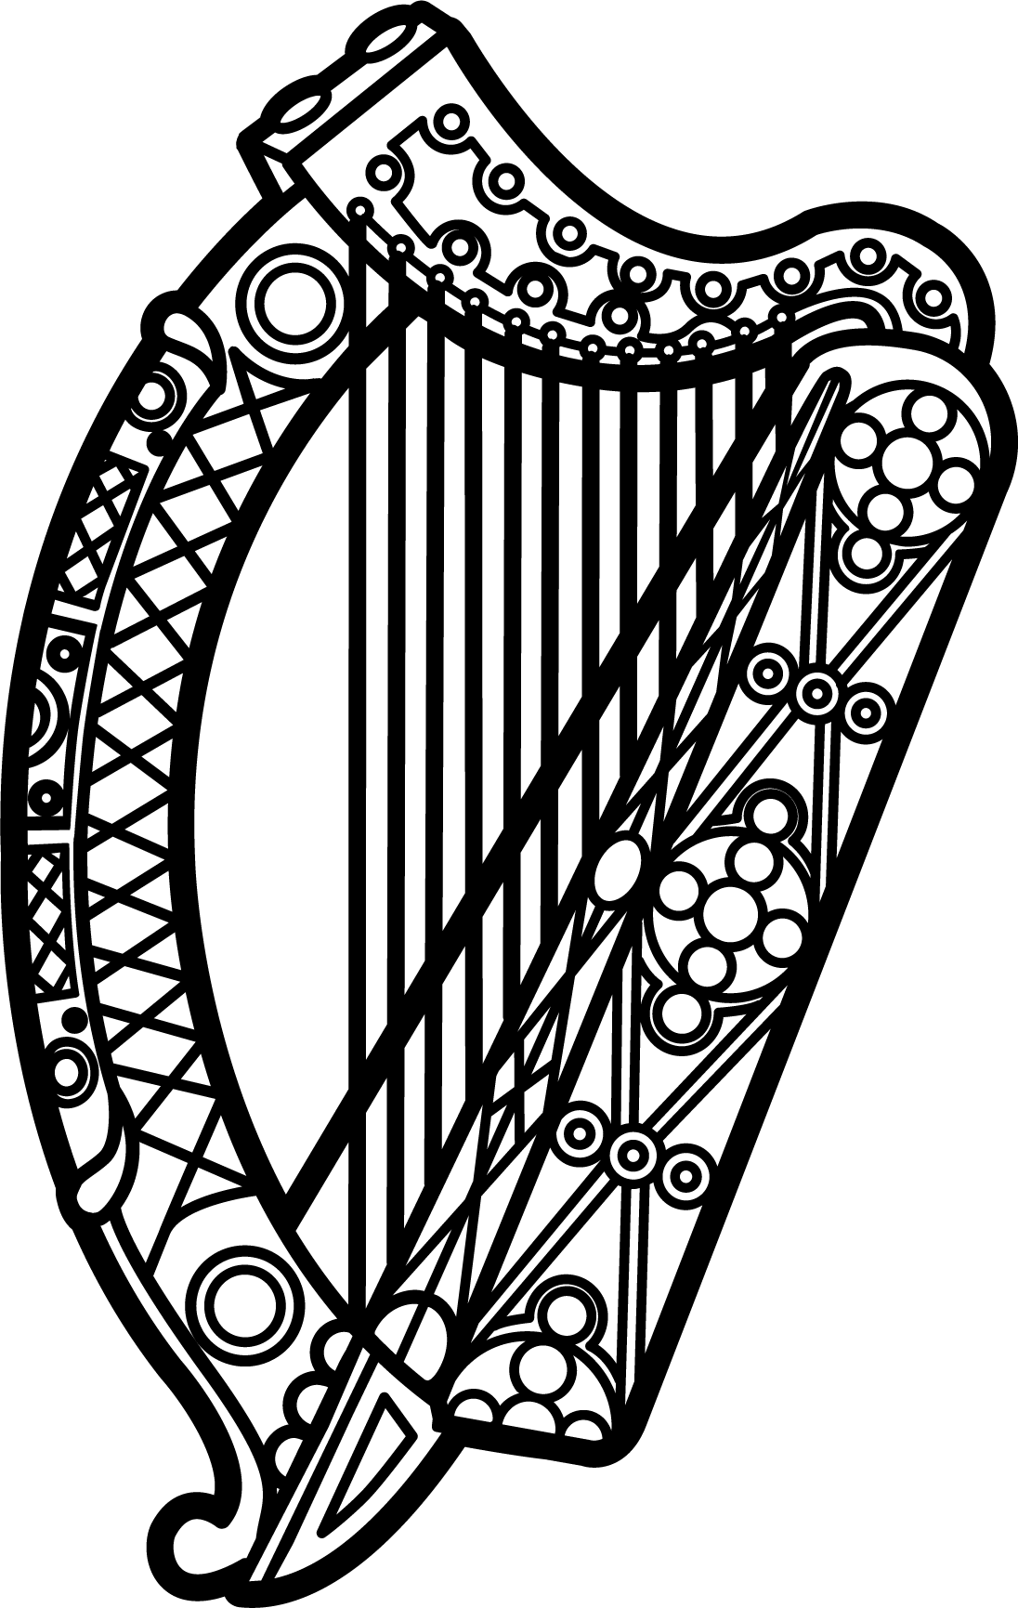

Statement of Ireland
34th session of the UPR Working Group

Review of Madagascar

11 November 2019

Thank you, Mr (Vice) President.

Ireland warmly welcomes the delegation of Madagascar and thanks them for their presentation.

Ireland acknowledges Madagascar’s efforts to advance human rights domestically and commends progress made since the last UPR cycle, in particular the adoption of legislation on the abolition of the death penalty and the accreditation of its NHRI to “A” status.

We also welcome that our previous recommendation to adopt a national strategy on gender-based violence was implemented. We encourage the Malagasy authorities to continue to ensure its full and effective implementation, including through the allocation of sufficient resources.

Ireland makes the following recommendations to Madagascar:

- Adopt the draft bill on gender-based violence establishing marital rape as a criminal offence, in line with recommendations of the CEDAW Committee.

- Implement existing legislative and policy frameworks on child labour and child, early and forced marriage, respectively, and develop a national strategy to combat all forms of child sexual exploitation.

We wish Madagascar every success with this UPR cycle.

Thank you.

