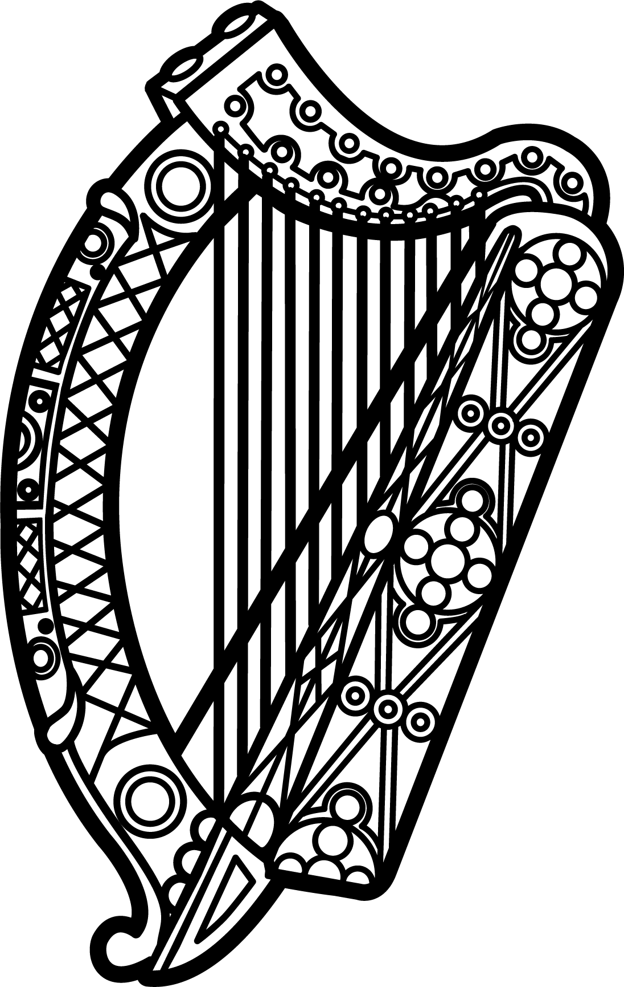

Statement of Ireland
34th session of the UPR Working Group

Review of Kazakhstan

7 November 2019

Thank you, Mr (Vice) President.

Ireland warmly welcomes the delegation of Kazakhstan and thanks them for their presentation.

Ireland acknowledges Kazakhstan’s efforts to advance human rights domestically since the last UPR cycle as well as its continued engagement with UN human rights mechanisms.

We remain concerned however, by reports of mass arrests, detentions and criminal prosecutions carried out by the Kazakhstani authorities against peaceful protestors, activists, journalists and lawyers during and after the presidential elections of 9 June.

We urge Kazakhstan to respect, protect and fulfil human rights in line with its obligations under international law and to follow up on recommendations of UN bodies, including the UN Special Rapporteur on the rights to freedom of peaceful assembly and of association.

Ireland makes the following recommendations to Kazakhstan:

- Ratify the Second Optional Protocol to the ICCPR, aiming at the abolition of the death penalty, and implement its provisions in national legislation.

- Amend restrictive laws regulating the rights to freedom of expression, association and peaceful assembly so that they are fully compliant with the ICCPR, in particular the provisions under articles 19 and 21.

We wish Kazakhstan every success with this UPR cycle.

Thank you.

