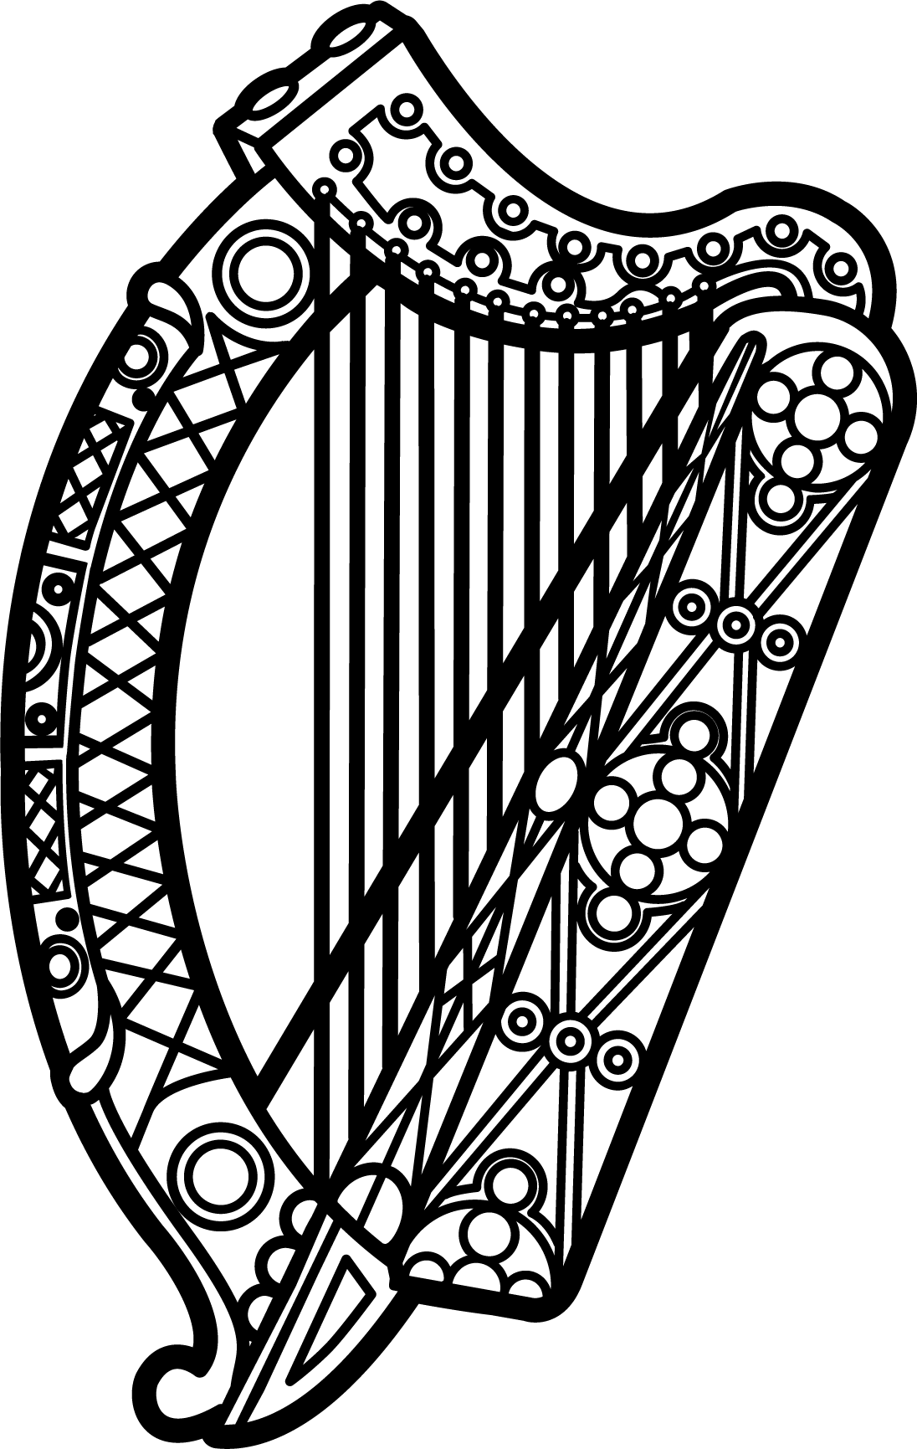

Statement of Ireland
34th session of the UPR Working Group

Review of Italy

4 November 2019

Thank you, Mr (Vice) President.

Ireland warmly welcomes the delegation of Italy and thanks them for their presentation.

Ireland commends Italy’s efforts to advance human rights domestically and progress made since the last UPR cycle. In particular, we welcome the adoption of strategies and actions plans addressing specific human rights issues, notably those relating to trafficking in human beings and discrimination against the Roma, Sinti and Caminanti communities.

Ireland notes that since Italy’s last Review in 2014, political and economic instability in neighbouring regions has resulted in an unprecedented number of individuals seeking refuge in Europe. Italy has received a significant number of these migrants and refugees and we welcome efforts by the Italian Government to respond to the challenges presented. Recent decisions to facilitate disembarkations from NGO rescue vessels operating in the Mediterranean are particularly welcome. We encourage the Italian authorities to take all steps necessary to protect and promote the human rights of migrants and refugees.

Ireland makes the following recommendations to the Italian authorities:

- Establish a national human rights institution, in accordance with the Paris Principles.

- Intensify efforts to combat discrimination, hate speech and hate crimes against lesbian, gay, bisexual, transgender and intersex persons.

We wish Italy every success with this UPR cycle.

Thank you.

