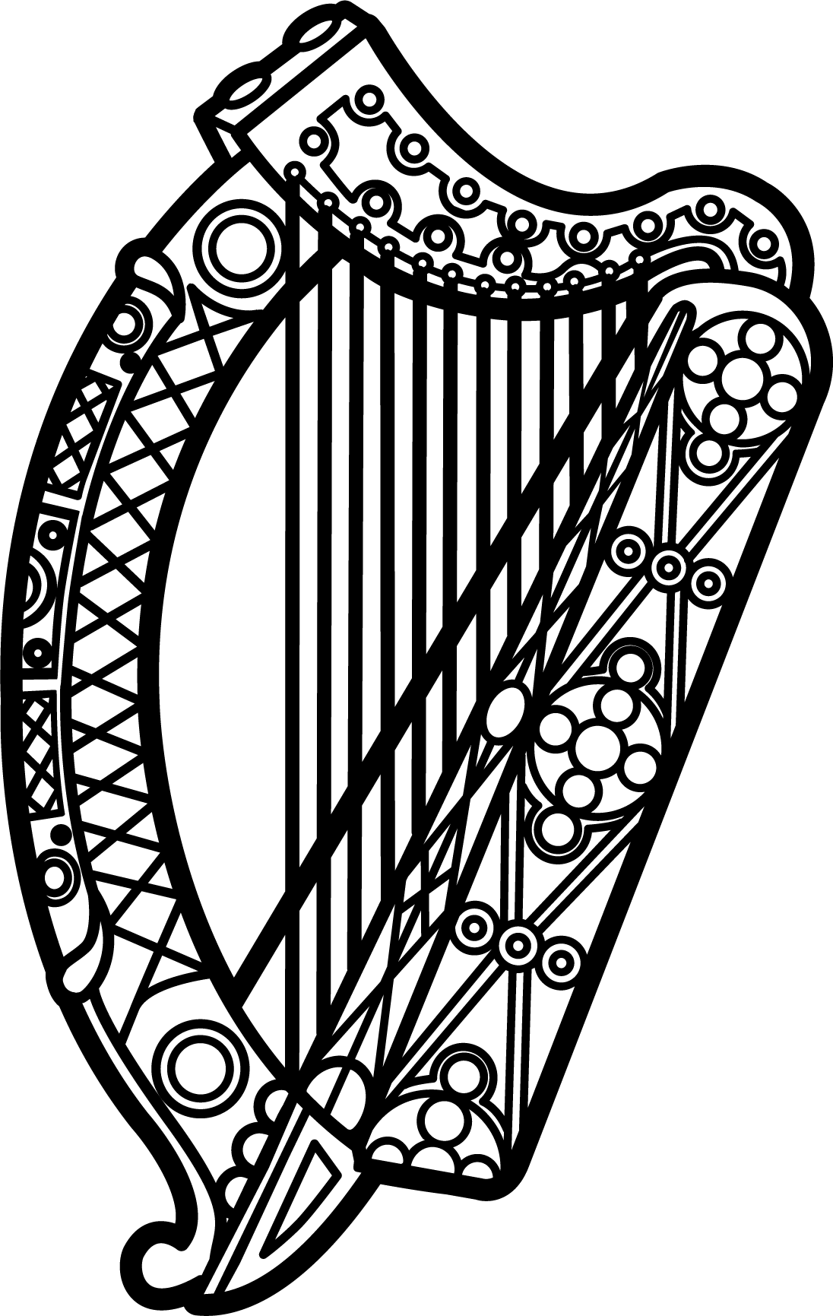

Statement of Ireland
34th session of the UPR Working Group

Review of the Gambia

5 November 2019

Thank you, Mr President.

Ireland warmly welcomes the delegation of the Gambia and thanks them for their presentation.

Ireland commends the Gambia’s recent efforts to strengthen democracy and human rights, and we acknowledge the progress made since the last UPR cycle. We particularly welcome the announcement of an official moratorium on the use of the death penalty and commend the Gambia for ratifying the Second Optional Protocol to the ICCPR earlier this year.

We encourage the Gambia to consider issuing a standing invitation to the special procedures of the Human Rights Council, and underline the importance of creating and maintaining a safe and enabling environment for civil society, including journalists and human rights defenders.

Ireland makes the following recommendations to the Gambian authorities:

- Amend or repeal all laws that unduly restrict freedom of expression, both online and offline, and decriminalise press-related offences such as defamation, libel, sedition and the publication of false information in accordance with international standards.

- Continue with efforts to permanently abolish the death penalty in all circumstances by amending the relevant provisions of the Constitution and the Criminal Code.

We wish the Gambia every success with this UPR cycle.

Thank you.

