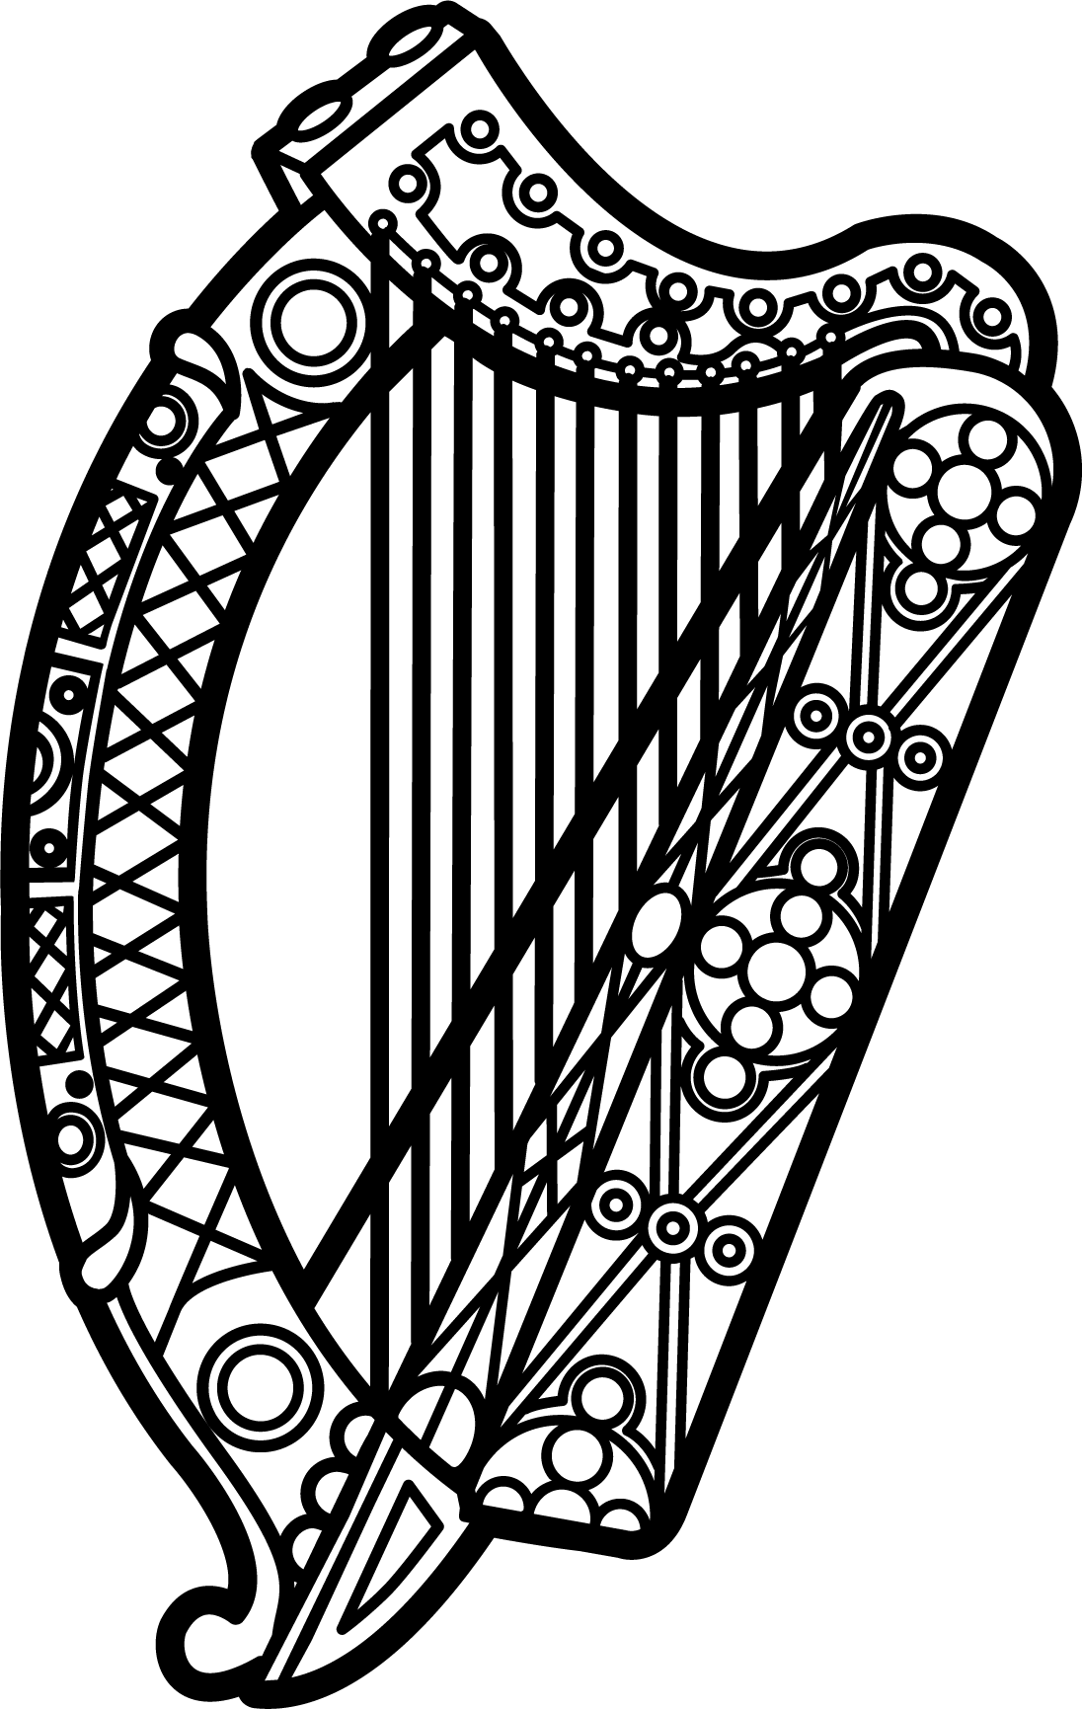

Statement of Ireland
34th session of the UPR Working Group

Review of Fiji

6 November 2019

Thank you, Mr (Vice) President.

Ireland warmly welcomes the delegation of Fiji and thanks them for their presentation.

Ireland commends Fiji for its determined efforts to advance human rights domestically and for the leadership it has shown in international fora through its Presidency of COP23 and its membership of the Human Rights Council—proving itself, in both instances, to be a strong and influential advocate for Small Island Developing States. Ireland was also proud to work alongside Fiji as co-facilitators of the SAMOA Pathway mid-term review, held earlier this year.

Ireland particularly welcomes the leadership that Fiji has shown on LGBTI issues at the Council, notably this year in supporting the renewal of the mandate of the Independent Expert on SOGI. We encourage the Government of Fiji to continue and intensify existing efforts to combat all forms of violence and discrimination based on sexual orientation and gender identity.

Ireland makes the following recommendations to the Fijian authorities:

- Ensure that the Human Rights and Anti-Discrimination Commission enjoys the human, financial and material resources necessary to discharge its mandate in full compliance with the Paris Principles.

- Take all necessary steps to ensure the full and effective implementation of laws and policy frameworks intended to combat and prevent violence against women and girls.

We wish Fiji every success with this UPR cycle.

Thank you.

