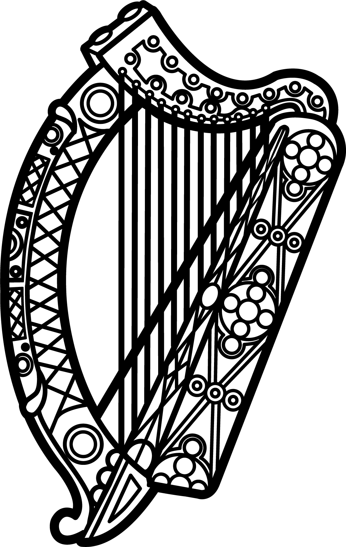

Statement of Ireland
34th session of the UPR Working Group

Review of El Salvador

4 November 2019

Thank you, Mr (Vice) President.

Ireland warmly welcomes the delegation of El Salvador and thanks them for their presentation.

Ireland acknowledges El Salvador’s efforts to advance human rights domestically since the last UPR cycle, including the adoption of the Second Optional Protocol to the ICCPR. We would encourage legislation to be passed as soon as possible to ensure its implementation in domestic law.

Ireland welcomes the peaceful transition of power earlier this year in El Salvador. We encourage the new government to continue to cooperate with UN human rights mechanisms and to follow up on key recommendations, particularly regarding the draft bill on transitional justice and concerns surrounding the functioning of its NHRI.

Ireland makes the following recommendations to El Salvador:

- Step up protection of human rights defenders and journalists and guarantee their right to work in a safe and enabling environment, including by conducting immediate, thorough and impartial investigations into all reported instances of threats, violence and intimidation against them.

- Increase efforts to prevent, combat and punish all acts of violence against women and girls, including by ensuring that the institutions and programmes involved in this work are provided with adequate human, financial and technical resources.

We wish El Salvador every success with this UPR cycle.

Thank you.

