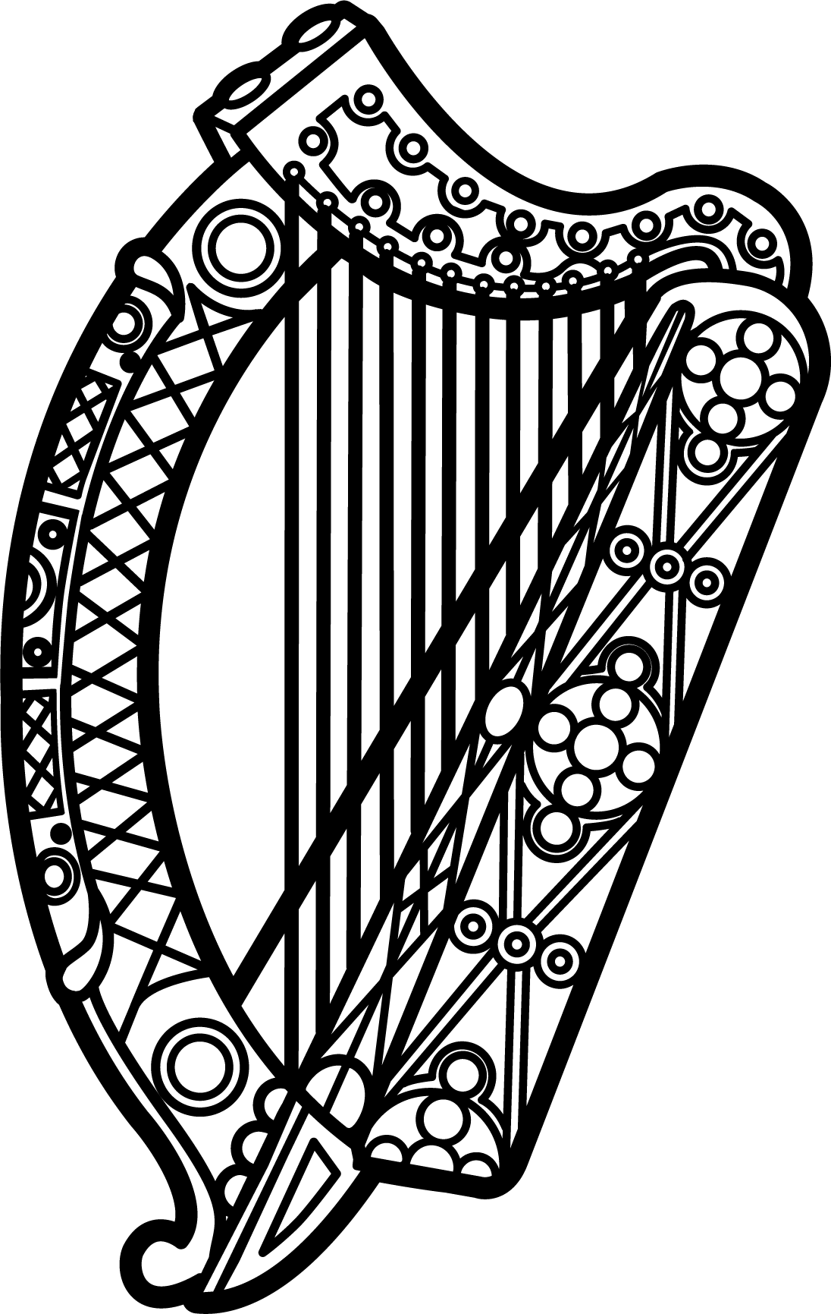

Statement of Ireland
34th session of the UPR Working Group

Review of Egypt

13 November 2019

Thank you, Mr (Vice) President.

Ireland warmly welcomes the delegation of Egypt and thanks them for their presentation.

Ireland recognises that respect for rights and freedoms is guaranteed by Egypt's constitution.

However, we are aware of reports of mistreatment of detainees, widespread and disproportionate detentions after recent protests, and of reprisals against human rights defenders.

Ireland recommends that Egypt:

- Ensure effective, credible and impartial investigations into all allegations of torture and ill-treatment against detainees contrary to [Article 55 of] the Egyptian Constitution and the UN Convention Against Torture, and ensure that perpetrators are held accountable.

- Release those detained for the exercise of their rights to freedom of expression, association or peaceful assembly, as enshrined in the ICCPR.

Thank you.

