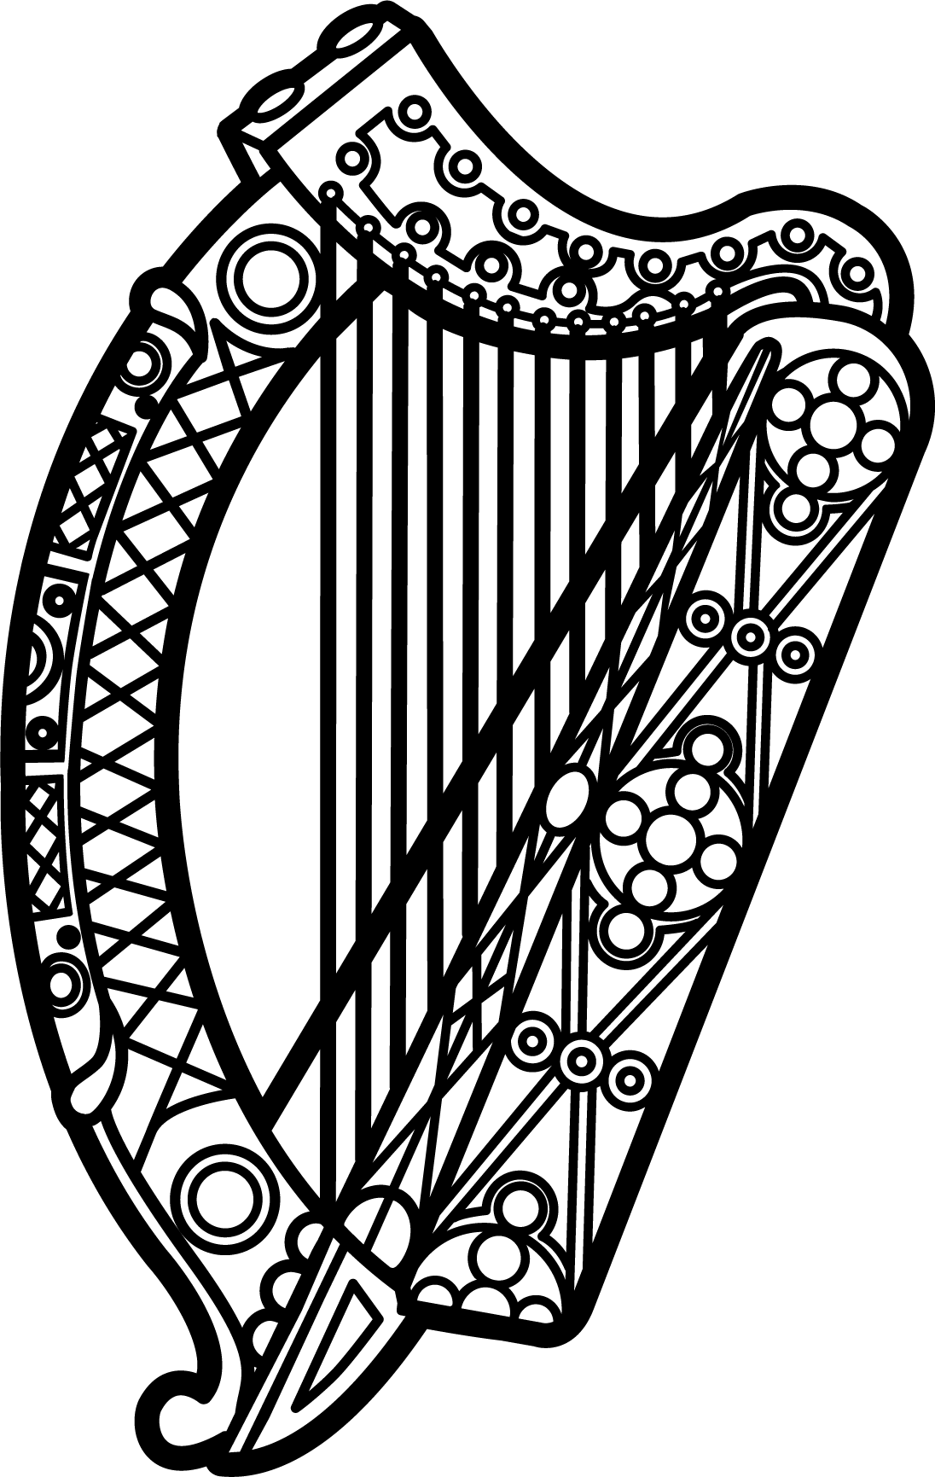

Statement of Ireland
34th session of the UPR Working Group

Review of Bosnia and Herzegovina

13 November 2019

Thank you, Mr (Vice) President.

Ireland warmly welcomes the delegation of Bosnia and Herzegovina and thanks them for their presentation.

Ireland acknowledges Bosnia and Herzegovina’s efforts to advance human rights domestically and commends progress made since the last UPR cycle. We welcome in particular the amendments to the law on prohibition of discrimination which extend the listed grounds for discrimination to age and disability, as well as sexual orientation, sexual characteristics and gender identity.

Ireland makes the following recommendations to the authorities of Bosnia and Herzegovina:

- Ensure that domestic legislation is aligned with the standards set by the Istanbul Convention on preventing and combating violence against women and domestic violence

- Ensure that the Office of the Ombudsman is provided with the financial and human resources needed to function effectively.

We wish Bosnia and Herzegovina every success with this UPR cycle.

Thank you.

