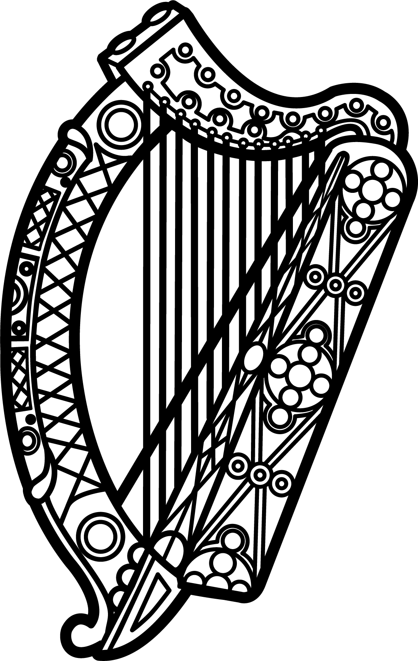

Statement of Ireland
34th session of the UPR Working Group

Review of Bolivia

5 November 2019

Thank you, Mr (Vice) President.

Ireland warmly welcomes the delegation of Bolivia and thanks them for their presentation.

Ireland acknowledges Bolivia’s efforts to advance human rights domestically and commends progress made since the last UPR cycle, including the establishment of the Truth Commission in 2016. We encourage Bolivia to take the necessary steps to ensure its independence and proper functioning, including by involving civil society in open and transparent consultations.

We are concerned by reports of violence and excessive use of force by the Bolivian authorities against protesters following the recent elections in October. We call on the government to uphold the rights to freedom of expression, association and peaceful assembly.

Ireland makes the following recommendations to the Bolivian authorities:

- Strengthen the institutions responsible for implementing the legal framework around violence against women, including Law 348, in order to improve access to justice and to ensure accountability and reparations for victims of gender-based violence.

- Strengthen efforts to protect LGBTI persons against violence and discrimination and tackle ongoing impunity for such acts, including through awareness campaigns and training programmes for judicial and legal bodies.

We wish Bolivia every success with this UPR cycle.
Thank you.

