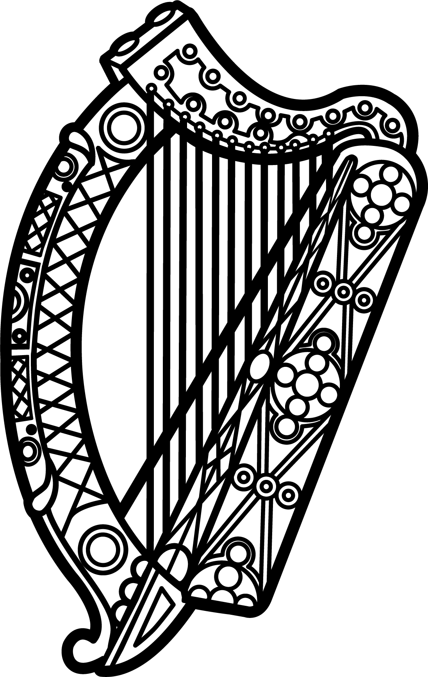

Statement of Ireland
34th session of the UPR Working Group

Review of Angola

7 November 2019

Thank you, Mr (Vice) President.

Ireland warmly welcomes the delegation of Angola and thanks them for their presentation.

Ireland acknowledges Angola’s efforts to advance human rights domestically and commends the recent ratification of CAT, ICERD and the Second Optional Protocol to the ICCPR. We encourage the Government of Angola to ensure that the provisions of all international human rights treaties, to which Angola is a party, are fully incorporated into domestic law.

Ireland also welcomes the adoption of a new Criminal Code in January 2019, which bans female genital mutilation, decriminalises same-sex relations, and prohibits discrimination on the basis of sexual orientation. We are concerned, however, that defamation remains a criminal offence and urge Angola to place it within a Civil Code in line with international standards.

Ireland makes the following recommendations to the Angolan authorities:

- Amend or repeal all laws that unduly restrict the rights to freedom of expression, association and peaceful assembly, and take additional measures to ensure journalists and human rights defenders are able to carry out their activities without fear or undue hindrance, obstruction, or legal and administrative harassment.

- Take further steps to guarantee the rights of gay, lesbian, trans, bisexual and intersex people by thoroughly investigating all allegations of attacks against them and by developing and implementing a national action plan to combat and prevent violence and discrimination based on sexual orientation and gender identity.

We wish Angola every success with this UPR cycle.

Thank you.

